**Khan's log**

**Star date 11/17/14**

We have spent the last few days in a hasty attempt to attach the Da Vinci tube to the drawer slides and we have encountered a problem. We have discovered that since the Da Vinci tube was designed to output the balls out its top end and down a small funnel, it was in need of a conveyor system to move the balls up its length against gravity. Since none of our attempts at a compact conveyor belt have succeeded, we are forced to come up with a different solution. We have thus decided to make the whole tube rotate upwards and let gravity work for us to take the balls to the back end of the tube. This however requires a massive hinge mechanism that adds a lot of weight to the top of the robot.

 

We have also encountered problems with the Da Vinci tube's intake system. Since the tube is a 3" diameter tube and the larger sized balls are 3" in diameter, it makes it difficult for the balls to get into the tube with just a simple brush. To fix this problem we have made some guides out of craft foam that act like a funnel to guide the balls into the tube.



**Khan's log**

**Star date 11/23/14**

Upon further testing, the weight of the hinge system that rotates the tube has proven too great for both the chassis and the winch motor that drives the drawer slides. In response to this problem, our team have put our heads together to create a compact conveyor belt that will actually work. We first looked to solve the problem of the conveyor belt slipping on its sprockets. To do this we selected a chain as the best candidate because chains do not easily slip. Second, we addressed the problem of mounting encourager paddles to a chain. In past experience, we have seen that we cannot attach things directly to a chain because the sprocket will simply bite them off. One idea we had was to somehow extend the pins that hold each chain link together and then simply attach our paddles outside the chain. We then experimented with several methods of extending the pins and have settled using nails. The nails that we have chosen fit the chain almost perfectly and give us mounting points on the outside of the chain to attach our paddles.



The new chain belt now alows us to remove the complex hinge that has been hindering our progres thus far and it also meens that we can use the Da Vinci tube the way it was origanaly intended.

Another problem we have encountered that is that since the nacelles are 3D printed with ABS plastic, they have a slight problem with bending just enough to let the gears slip. This problem has an amplified effect whene the robot has the weight of a riser system and intake tube. Due to the slipping problem, the robot struggles to turn and drives poorly. To fix this problem, we have designed sheet metal "shin guards" to reinforce the nacelles.



**Khan's log**

**Star date 11/27/14**

Happy Thanksgiving! This past week of break has given us the time we needed to put the finishing touches on the robot. We have also now had the time to make a claw system for grabbing on to the rolling goals. It is a simple pair of pegs that are rotated down by a servo to capture the base of the rolling goal. We also finished integrating our light system.

 

**Khan's log**

**Star date 12/6/14**

Today two of our team members went to watch our sister team (452 PHI Alpha) compete in Monrovia CA. While there we had the opportunity to scout out other teams designs and gain some lessons learned without having to compete. We gathered a wealth of useful information and also were able to offer assistance to several teams that were in need of help. We also where able to see what designs worked well and what designs did not. After the day of scouting and compiling designs, we have come to a realization that our robot needs some dramatic changes.

* Our intake needs to be way more reliable.
* Our lift mechanism needs to be able to reach the center endgame goal reliably.
* Our output end needs to have some device to stop the balls from rolling over the mouth of the tube.

We also made an observation that several teams were getting their wheels hung up inside the rolling goals bases. Our suspension however can drive right over these bases with no such problem.

After some further design revision and brainstorming, we have worked out a concept design of what we would like our robot to work and look like.



Our sister team 452 PHI Alpha was also kind enough to give us a copy of their lessons learned from the Monrovia competition.



**Khan's log**

**Star date 12/8/14**

We have already completed a promising prototype for the new intake scoop and are ready to move on to production. We will send off some dimensions to NASA Armstrong to have the scoop plate manufactured professionally.



**Khan's log**

**Star date 12/10/14**

We have made substantial progress since our last log entry. We stripped the robot down to the KR4 chassis and got rid of all the Da Vinci tube madness and drawer slides. The "shin guards" however have not been effective enough to stop the gear slipping problem so we have decided to switch to chain instead of direct gearing on the drive wheels.



We have also decided to switch our winch over to chain to stop it from slipping as well. Using a dremal we have cut out the pieces for the new intake scoop and the bucket from the CAD model. We sent off dimensions for the sheet metal scoop plate to NASA Armstrong to be metal shopped. However NASA misinterpreted our request and bent the wrong piece of metal. Luckily, we were able to fix the damage and re bend the part on our own. We have opted to use rivets on the new components due to their flush nature.



We have encountered some setbacks regarding the type of plastic we are using for the scoop and bucket. The plastic is remarkably brittle and tends to shatter while it is being drilled through or being riveted. This problem has been addressed with a liberal application of duck tape.



We have also perfected our design of an output funnel that folds flat to act as a door but extends out to make an enclosed tube for the balls travel down.

 

**Khan's log**

**Star date 1/1/15**

Happy New Year! With the start of the new year we now have a little more than two weeks until our first competition in Paris Lake, CA. With the competition approaching we are moving towards driver practice and software work. With the first few rounds of driver practice we have noticed some wear on the robots 3D printed parts. The motor screws on the nacelles have begun to wear away at the plastic underneath them and one of the plastic brackets that holds the cross spars and the rails together has sheered in half. Luckily we have a spare bracket but after the shattered nacelle incident earlier this year we have no spare nacelles. We are currently working to make a request to NASA Armstrong to have a new set of parts printed. Also we have found that our wiring system is a bit too compact for some of the team members to use so we are working on rearranging the motor controllers within the cross spares.

**Khan's log**

**Star date 1/8/15**

Tonight is a night for final touches and fixes as well as driver practice and judging practice. One fix that was made was the implementation of fillers in the nacelles. They are made of a 1" aluminum rectangular tubes that are inserted into the nacelles to give them stiffness.



We have also noticed that the drawer slides hit the back right motor when they come back down. To fix this anomaly we are utilizing the modular nature of the KR4 chassis. The Brackets can be unscrewed from the rails and the whole center of the robot can be slid forward on the rails to make space for the slides.

For the remaining two days we will continue driver practice and autonomy writing. The robot needs servo hooks remounted on the back of the robot. PERRIS HERE WE COME!



**Khan's log**

**Star date 1/15/15**

The Perris Lake competition went decently well. We encountered no major problems within the robot’s systems. There is room for improvement, however. For example, our zip-tie brush pulls balls in, but they tend to get stuck just behind the motor powering it or hover right at the back of the intake chute without going into the bucket. We cannot afford any time for hardware changes with the Palmdale competition right around the corner this weekend. Instead, one of our team members is prototyping a new intake mechanism consisting of an upright conveyor belt to pick up the balls easier.



This conveyor should allow for a more efficient intake of balls while taking up the same space the original intake used. The proposed backstop for the balls to hit will sit just far enough off the ground to avoid the unwanted picking up of small balls, creating a passive sorting system. For now, we have given the robot in its current form over to the software and drive team for extra practice for the competition.

**Khan's log**

**Star date 1/29/15**

We’re back from the Palmdale competition, and with multiple sets of good news! First of all, we did great at the competition. This wasn’t easy, however. We encountered a new bug in the robot. As we rolled along the field, the robot would build up a static charge, then randomly send this shock to the NXT and freeze it. This happened multiple times during the matches. The quick fix was to put a grounding wire on the bottom of the bot, but we have an order in for NXT surge protectors that were released this year. Secondly, we made contact at the competition with a previous valley robotics team member who now works at the company Scaled Composites, who built Spaceship One. He works in the carbon fiber department and has agreed to create our shields for us in this way. We have handed the dimensions over to him and are waiting to get the new shields back. In the meantime, we decided to prepare the robot for the installation of the new conveyor belt intake system by pulling the old brush intake off the robot.



It came off easily, as we had mounted it with a simple four screws. While we waited for the conveyor to get mounted, we made a small change to our servo wires going up to our bucket. During the competition we noticed one of the teams had used a coiled phone wire to lead up a linear slide system. We were unaware this was legal, so we talked to them and solidified that we could use it legally. We have now soldered two of the new servo wires and have them mounted on the robot. By the end of the night, we got the conveyor mounted and tested, finalizing it for our next competition.



We will now hand the robot back over to software and the drive team for extra practice and finalization of our strategy. Be ready Las Vegas! Here comes Khan!

**Khan's log**

**Star date 2/13/15**

So Vegas went mildly well. We failed to make it to semi finals and struggled with the robots static errors. We did however succeed at winning the Innovate award for the advanced nature of our robots sub systems such as suspension. After returning home, we immediately got to work on improving our robot. We have done some experimenting with a new light sensor that will run through the prototype board. However unlike a normal Lego sensor, this sensor does not provide its own light so we have had to rig up our own light source.

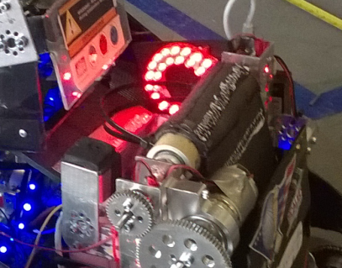 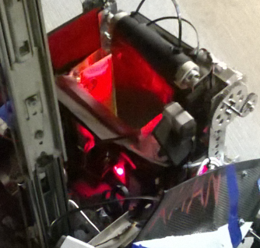

The next problem we addressed was our short circuiting problem. We determined that the paint on the chassis has been storing static and releasing it into the motor controllers and NXT. Our first change has been a complete rewiring of the robot. During the rewiring we changed our daisy chain to a set of power distribution boxes to more evenly provide power to the motor controllers. We have also mounted a surge protector in the middle of the USB cable going from the NXT to the Samantha unit. After that we remounted the motor controllers to the back of the intake to isolate them from the chassis. We then routed the NXT information wires along the top of the intake to protect them from the power cables.

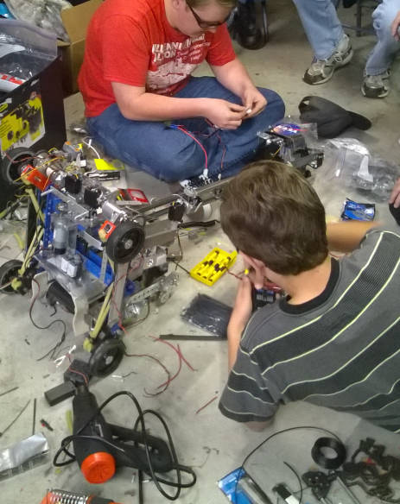

After all the important things where completed, we wired in our running lights to the robot's prototype board.

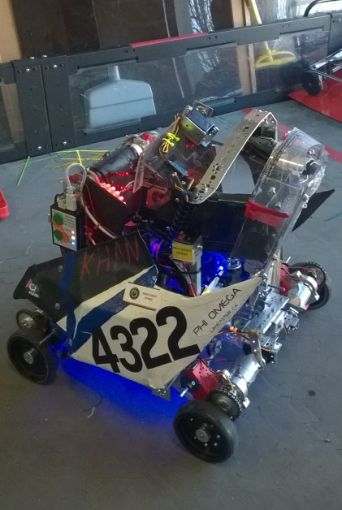 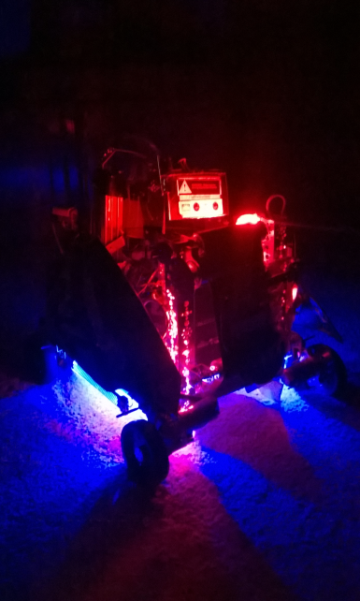

Ready or not Monrovia championship here we come!

**Khan's log**

**Star date 3/12/15**

So we did much better than expected at Monrovia. WE QUALIFIED FOR SUPER REGIONALS!!!!! We did not think that we qualified and had completely accepted the fact that our season was done but then we got an email from FIRST saying we qualified so it's all hands on deck to get this robot ready. The first item of business has been to get a more efficient lift working. We have been looking into the use of 80-20 slides to replace our drawer slides. After doing some research we have decided to try to use our own 3D printed adapters rather than spend $200 on professional grade adapters.

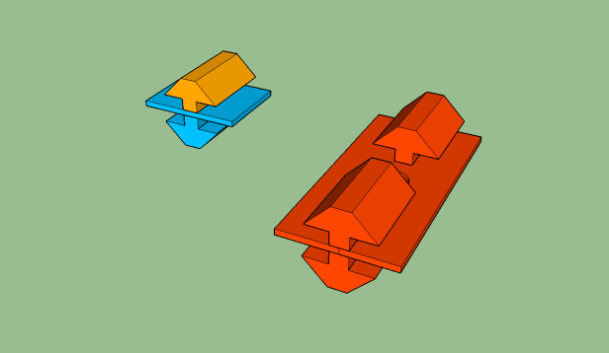

After some further research, we have decided to stick with our current drawers due to the complex nature of the 80-20 slides and our limited time frame. In light of this decision, we have discovered a way of re tensioning the lateral support band on the slides. By using this process, we have successfully adjusted our lift to raise straight up. We have also made two spare plastic buckets for the arm and three spare output flaps. These spares are made to be modular and be able to mounted to the robot in a matter of minutes. Another spare/replacement that we had made for us was the metal support strap over the top of the bucket. Our old strap was made out of a 12" TETRIX stip. The TETRIX strip however proved to be brittle and broke several times. For a replacement, we contacted our associates at the NASA Armstrong metal shop to get a new strap made out of a stronger metal. After sending off dimensions, they cut out some 12" strips of 800 series aluminum. We then bent the strips into shape and drilled mounting holes to attach them to the new buckets. The final item that we had to address was the perennial static problem the robot has been dealing with. One of our greatest discoveries that we made was that our intake belt was acting as a Vandergrift generator creating and storing static. To solve this problem, we attached a copper ground wire on the intake rubbing on the back of the belt. Another solution to the problem is a new procedure to pretreat the robot before each match by rubbing it down with anti static drier sheets then misting the robot with soap water to remove all the static built up in previous matches. With these new changes we have seen a dramatic decrease in NXT freezes due to static. We now have decided to freeze all hardware changes and proceed with driver practice.

SUPER REGIONALS HERE WE COME!!!!!!!!!!!!!!!!!!!!!!!!!!!!!!

# SOFTWARE



**Tele-Op**

One thing that our team is very proud of with our tele-ops is our use of stick-shaping. Stick shaping is when you don't just apply the direct joystick value to the power or speed of the motor. The power or speed is determined by “shaping” the value of the joystick using a non-linear function. We generally use a cubic function to define how to apply power values to the motors. **Our main use for it is to allow for higher precision by using a graph that dictates the less you move the joystick, it will move the robot even less.** This could be done by just capping the maximum power and taking some static percentage of the joystick value however, we value our speed and still wish to be able to reach 100% power. Our solution is stick shaping. The equation we are using this year is shown in Figure 1-1. is

Another thing we do in our tele-op program is multitasking. We use the built-in task features that RobotC implements for the NXT. **We use multitasking** for a few different reasons. Firstly,we use it **because it** **lessens the likelihood of your program completely freezing from an error in the code**. By breaking it into tasks, even if one task runs into an issue, the others can continue and will not necessarily be inhibited by the problem.Another reason we use multitasking is **to separate our drive from our other functions**. Drive is a very time-consuming task and you often want immediate response from your controller. If your robot is stuck performing some other calculation or check, then it halts your drive and brings a higher latency into play. We avoid this by allowing everything to be compartmentalized and handled separately. One more major reason we use multitasking is our “Watchdog” program. We program **it to monitor for a disconnection from the Field Control Software**. As soon as this watchdog stops receiving messages, it realizes that something is wrong and starts killing other tasks. This is important because normally, if the messages stop, they cannot update your controller state making the robot not only unresponsive but condemned to perform whatever tasks that controller state dictates it should. This can often cause the robot to ram a wall in a driving period and cause physical problems as parts are juddered loose. After watchdog stops all tasks except itself, it starts to monitor for messages to start coming in again. Once it sees that the messages are coming and a connection has been reestablished, it restarts the tasks so that the robot can continue functioning. This is shown in Figure 1-2.

Figure 1-1

Figure 1-2

This year there is a limit on the number of balls you can control at one time. In the midst of a match, it can be difficult to ascertain whether you have the full five balls you are permitted to have in possession. We solve this by **counting the balls with a 3rd party analog light sensor attatched to the Prototype board and turn on our lights (by allowing current to flow through a transisitor) when 5 balls are counted**. We know a ball has passed when there is a major decrease in the intensity of light read by the light sensor as the balls block the flow of light ususally sensed directly oppisite the sensor.

**Tele-Op Controller Layout 1 (Single-Stick Drive)**

Drive Control

Output Flap Control

Ball Storage Flap Control

Conveyor Belt Control

Hook Control

Drive Mode Switch

Lift Control

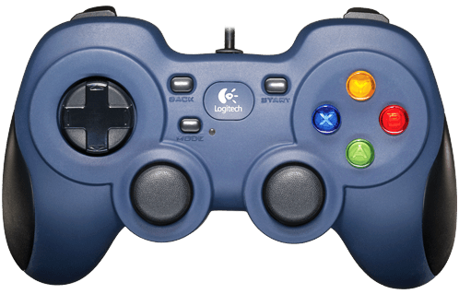

Drive Control

**Tele-Op Controller Layout 2 (Tank Drive)**

Left Drive Control

Right Drive Control

Output Flap Control

Ball Storage Flap Control

Conveyor Belt Control

Lift Control

Hook Control

Drive Mode Switch

**Autonomies**

One of our main focuses this year has been autonomies. One of the awards that we found interesting was the Control award. There are several Seniors on the team this year that are wishing to leave there legacy on the team for future years. One way they wish to do this is with a more intelligent autonomous period. Intelligent and dynamic autonomous control is one way to greatly improve the accuracy and success during the autonomous period. The main way that this is accomplished is by introducing more sensors into the build.

**Sensors**

Encoders- An encoder is a rotational tracker. It uses ticks on a disk and a reader. The disk is secured on a motor axle and as the ticks pass by the reader, it records it for the NXT. We can use this information to know how much our motor has rotated. One thing we generally do is only have encoders on one motor per side to increase efficient use of our resources. One thing that this does though is defeat the purpose of using the built-in PID control provided by RobotC.

We like to use PID control during both tele-op and the autonomous period for more consistent control and so this provided us with an opportunity. One way we did this was by adding a smooth ramp down function based on a negative natural log curve. We also decided to create our own basic PID control. Not only would it maintain a speed for the motors, but we wished to be able to set this speed for the autonomous period using a more relatable unit of measurement such as inches per second. First, we implemented a very simplified version of PID control by constantly measuring the speed of the robot in encoder ticks per second calculating the derivative of encoder ticks passed with respect to time. We then calculate the error in this by finding the difference between the current speed and the desired speed and then add a weighted version of this to the relevant motor’s power. (We are still currently working with this software to try to get it working reliably. We cannot take readings in a small enough time period to accurately derive our speed) However, all of this takes place in encoder tick-based measurements. In order to allow the use of a standard we are familiar with, we convert the input (which is in inches) to encoder counts by calculating and multiplying by a “counts per inch” constant. This can be calculated by dividing the total encoder counts by the circumference of the wheel multiplied by the gearing ratio. For us this becomes: $\frac{720}{4*2π*\left(\frac{2}{1}\right)}≈14.32$. Due to physical factors however, such as tire wear and slack in the chain, this must still be calibrated slightly to increase accuracy using trial and error. Our PID control is shown in Figure 1-3.

Gyro- A gyro measures angular velocity. It sends the NXT data about how fast it is turning in degrees per second. We can integrate this information with respect to time to calculate our angle turned. We use trapezoidal integration for this task. We chose trapezoidal because it is simple to implement without requiring heavy processing while still reducing error compared to simpler methods. The equation for this is stated in Figure 1-4. This translates into: The angle turned equals the sum of multiplying half of the time passed by the sum of the current gyro reading and the previous one for all intervals of time. The main source of error in a gyro is known as drift. This is caused by physical imperfections such as (miniscule) weight offsets within the sensor itself as nothing can ever be made quite perfectly. What we do to compensate for this is take a “gyro bias” before using it. This basically gives a starting reference of error that can then be subtracted from the data to remove the error. It is also minimized in that we are not using it long enough for it to accumulate significantly. Figure 1-5 gives a visual representation of the concept of trapezoidal integration. The “Y” axis is the gyro values while time is on the “t” axis. 

Figure 1-4

$$∆A= \sum{\frac{∆t}{2}({gyroSample}_{0}+ {gyroSample}_{1})}$$

Figure 1-3

Accelerometer- An accelerometer measures the acceleration of the robot. This has many purposes. One of the main uses is to measure orientation relative to the ground. This works because since gravity is acceleration, the accelerometer reports this. By using some basic trigonometric functions, you can calculate how much of an angle there is between standard gravity and the acceleration on your appropriate axis. In Figure 1-6, the “Y+/-”axis would be perpendicular to the ground while the other two are parallel. As a result, that is the axis that would report the acceleration due to gravity. This can be used to calculate the angle of the robot according to either of the other axis using the equation in Figure 1-7. Considering our goal to add new autonomous functions to our programming to make us stand out, we looked at the accelerometer from a different perspective.

Figure 1-6

Figure 1-5

$$Atan(\frac{desiredOrientationAxis}{Y})$$

Figure 1-7

We decided to challenge ourselves with the task of calculating distance using only the accelerometer. This is theoretically possible due to the fact that acceleration is the second derivative of displacement so getting displacement from acceleration is a simple matter of double integrating your acceleration values to get displacement. This does not quite work so well in a practical environment however as with the gyro, a similar error begins to build up in the accelerometer. One reason for this is that we cannot guarantee a constant acceleration and our sampling rate is limited by hardware capabilities. Ideally, you would have to get the instant acceleration for infinite points in time to accurately calculate displacement when acceleration is non-constant. Since this is impossible, we have to assume a constant acceleration between samples. Since this is not actually the case, we begin to accumulate error which just keeps increasing. We decided again to use trapezoidal integration for this task. It is very similar to the one used for the gyro with the exception that it is performed twice now. We mostly succeeded in gathering our displacement from acceleration with the exception of it not being as accurate as would be practical for competition. Our average error margin was +-4 inches. Since our encoder-based move function is more accurate, we mainly use that for competition and continue work on this. We are however, using the acceleration-based move function to perform our initial move in our IR seeking autonomy since it is less accuracy dependent at first as a demonstration. There is recorded test data for one run in Appendix A.

IR-The IR sensor senses infrared light of a certain frequency. It is actually composed of 4 separate IR sensors which are encapsulated within it. These provide the intensity of the signal that they find and the overall sensor calculates that and determines the “region” that the signal is coming from. There are thin regions and wider regions (as shown in Figure 1-8) and we try to use the thinner ones to increase accuracy. One thing that we found this year in particular is that from no place on the ramp could you determine a unique IR region for each of the three possible IR beacon positions. Anywhere we checked on the ramp, we received the same region for two positions of the beacon and then a unique region for the third. We decided not to use this method of determining orientation as a result. Instead, we decided to approach this from a mathematical and dynamic perspective. Rather than store routes based on the orientation of the center goal, we will “seek” out the IR beacon and drive to it, accurately orienting our robot along the way. This is done by pairing the ultrasonic and the IR sensors. First, the servo-mounted IR is used to calculate our angle relative to the beacon. We then make ourselves perpendicular to the beacon by turning enough to set us perpendicular to the beacon. We then drive closer to the IR beacon and use the ultrasonic to constantly make minor adjustments to set us at the correct distance from the goal.

Figure 1-8

Ultrasonic – The ultrasonic is finds the distance from itself to an object directly in front of it. It uses the same method as a bat in that it sends out a high frequency sound wave and waits to receive it. It calculates the distance that wave travelled by recording the time it took for the wave to come back. The sound wave travels at a set velocity and so this can be derived with respect to the time that it took to calculate the distance the wave travelled. Only half of this distance is how far away the object in front of it is and so this is what is reported to the NXT. We are using the ultrasonic to precisely align our robot with various game components on the field. Our ultrasonic sensor is mounted on a servo. We rotate this servo until we read a roughly constant distance for a calibrated number of servo clicks. When this condition is met, we calculate the angle of the servo relative to our robot and turn opposite this angle to correct it. This is repeated until we are perpendicular to the desired object and then we drive forward until we are a predetermined distance away.

 With these sensor improvements in progress, we are also trying to open up more room and potential for others by incorporating a prototype board. We are currently experimenting with a 3rd party 10-dof IMU named the GY-80. The key components of it are a three-axis accelerometer as well as a three-axis gyro. One complication with this is that the IMU uses I2C to communicate with its master and the prototype board does not natively support acting as a master. This means that a software master must be coded to bit bang the sensor. One advantage of this is that when complete, we will be able to add up to 128 sensors per 2 digital pins on the prototype board. We are currently using an I2C master library created by Lex Robotics, FTC team 4029. We found through various tests however, that this method does not work well for integrating real time data as it took us about 3.8 seconds to actually retrieve our acceleration data from the sensor and integration is very time sensitive as you want the smallest interval length you can manage. This version of I2C takes so long because I2C is based in the flipping of two digital pins HIGH and LOW. To flip a pin on the prototype board, an entire byte must be sent via I2C to the board. This means that for each byte of data we want to retrieve, we must send over 60 bytes to the board! Figure 1-9 shows how I2C protocol works.

Figure 1-9

Our last major development we are working on so far is a program we are creating that allows for non-programmers to quickly and easily create autonomy for the robot. It is in its early stages and isn’t extremely capable yet, but the concept is there and has a foundation. It currently generates a list of commands in a list on its side which give accurate movement values based on lines the user draws on a scale-representation of the field. It converts the pixels covered by a line to inches and calculates the angles between any two consecutive lines that are drawn. The generated image showing routes can then be saved as a png file. We plan to make this more dynamic so that it can be used with any game and will actually generate the complete C file for you.

**Autonomous Strategy**

Figure 1-10 is a screenshot of the current state of the graphical autonomous designer we are designing. It currently works well enough to use the picture generated and to copy and paste the commands into an autonomy program.

Figure 1-10



Our main autonomous strategy is to drive off of the ramp, line up with a tube, collect a tube, drop a preload into the tube, and then carry the tube the remaining way to the parking zone. We have other strategies as well based on the capabilities of our alliance partners. These are described in appendix E.



# FUNDRAISING

PHI Robotics, a 501(c)(3) nonprofit organization, is the greater umbrella over both our team and our sister team PHI Alpha. Since we operate as one team, we share sponsors, funds, and a budget.

PHI is sponsored by corporations, private individuals, and our own fundraising events. Our corporate sponsors are Lockheed Martin, NASA, and Northrop Grumman. Lockheed Martin has generously given us funds, and NASA buys us parts and machines custom parts for us. Northrop Grumman also gives us funds. Our fundraising events have included everything from demonstrating our robots at restaurant events, selling Yankee candles, and hosting garage sales.

We seek to use our money wisely, which includes using it to help other teams. We fund two local FIRST LEGO League teams, and help fund another FTC team. In previous years we have also used our funds to host qualifying tournaments for the LA region.



The team’s budget for this year:

|  |  |  |  |  |  |  |  |
| --- | --- | --- | --- | --- | --- | --- | --- |
| Expenses |  | Price |  | Income | | | Amount |
| Registration |  | $750 | | | Parents |  | | | $675 |
| Tournaments |  | $500 | | | Yankee Candle Fundraiser |  | | | $500 |
| Shirts/Labcoats |  | *PBP | | | Garage Sale Fundraiser |  | | | $300 |
| Parts |  | $1,660 | | | Sweet Frog Fundraiser |  | | | $ |
|  | Tetrix | $900 | | | Private Donations |  | | |  |
|  | Andy Mark | $400 | | |  | Lockheed Martin | | | $750 |
|  | Home Depot | $150 | | |  | Northrop Grumman | | | $5,500 |
|  | Master Carr | $100 | | |  | NASA | | | $275 |
|  | Karl's | $30 | | | Total |  | | | $8,000 |
|  | 99 Cents Store | $10 | | | (Due to two teams this value is cut in half.) |  | | |  |
|  | Staples | $40 | | |  | 452 | | | $4,000 |
|  | Michaels | $30 | | |  | 4322 | | | $4,000 |
| Travel |  | *PBP | | |  |  | | |  |
| Office Supplies |  | $40 | | |  |  | | |  |
| Field |  | $450 | | |  |  | | |  |
| Lego Teams |  | $700 | | |  |  | | |  |
| Batteries |  | $40 | | |  |  | | |  |
| Tools |  | $100 | | |  |  | | |  |
|  |  |  | | | Material Donations |  | | |  |
| Total |  | $4,240 | | |  | NASA | | | $700 |
|  |  |  | | |  | Spirent Communications | | | $10 |
|  |  |  | | |  | Scaled Composites | | | $100 |
| *PBP Paid By Parents |  |  | | | Total |  | | | $810 |



# TEAM ORGANIZATION

**TEAM ORGANIZATION:**

**PHI Omega and PHI Alpha:**

PHI Robotics actually isn’t registered as one team- it’s registered as two. However, even though PHI Omega and PHI Alpha compete as separate teams, build two different robots, and consist of different team members, they come together to form the organization PHI Robotics. Although the teams often seem very different, PHI as a whole operates more as one team than two. Members of both teams share ideas, prototypes, and help each other whenever help is needed.

PHI Alpha and PHI Omega also share funds and parts. They fundraise together, and also joint-hosted the 2014 High Desert Qualifying Tournament. All in all, even though the teams can look very different from the outside, they really come together to make up a larger team- PHI Robotics.

In the beginning of the year, PHI Robotics begins as one team, but as prototypes are developed and integrated onto basic chassis, the teams begin to form naturally. After a few months of working with this, PHI has usually divided naturally into PHI Alpha and PHI Omega. These teams don’t always change much from year to year, however, with the exception of new members joining the team and senior members’ graduation. Jonathan, Jacob, Mike, Eddie, and Kaitlin were all members of PHI Omega during the 2012-2013 season and some of the older members were even part of Omega the previous year.

**PHI Omega’s Organization:**

PHI Omega also has its own team structure. As the most senior member, Jonathan leads the team over all, as well as taking leadership in the hardware area. This year he is mentoring three new members- Anna, Hanna, and Sergei- in hardware. Eddie also helps with hardware, though he is also a member of the software team.

   

*The hardware team*

Noah, Eddie, and Becky make up the software team and are responsible for programming the robot. Noah is the software captain and does much of the major programming, and Becky is learning software from him and Eddie.

  

*The software team*

Kaitlin and Holly coordinate the Engineering Notebook. However, even though they coordinate the notebook, the rest of the team works primarily on their respective sections- the hardware team handles the hardware section, the software team the software section, and so on. All members work on the meeting log, as well as adding to the outreach section and other general sections.

** **

*The notebook team*

**The Mentors:**

Of course, no team would be complete without their mentors. Although PHI works primarily on its own, its mentors offer feedback on their designs, keep the teams focused, and help them plan and manage their time wisely. By helping us learn these skills, they help prepare us for life.

The Stinsons have been running PHI for seven years as an FTC team, and for even longer since PHI was first a VEX robotics team. Over the years they have generously opened up their house to us, first allowing PHI to work in an upper room and then, as the team expanded, giving the team their entire garage. Even after Dylan graduated from robotics, they continue to host the team and keep it running. They also have given much time and effort to helping prepare for the High Desert Qualifying Tournament in the two years it has run (2013 and 2014). PHI is greatly blessed to have such amazing mentors.

Dylan himself is a graduated PHI mentor and a computer genious. It has been said that all Dylan has to do is walk into a room and immediately all the electronics begin to work. At the High Desert Qualifying Tournament which PHI hosted, Dylan kept the software running as smoothly as possible. Now he helps guide our software team in the right direction when they get stuck on a tough coding problem. When he’s not offering advice on software or doing college work, Dylan designs drills to help keep the team in peak driving condition.

Mr. Pierce and Mr. Cox are new mentors to PHI as of the 2014-2015 season. But although this is their first year mentoring, both have experience with PHI from their childrens’ time on the team.

# PROMOTE VIDEO



**Promote Award Video Entry:**

This year Phi Robotics decided to make an entry for the Promote Award. Both Phi Alpha and Phi Omega collaborated to make a video submission for the award. The teams came together and submitted their answers to this year’s challenge- Why I Chose FIRST. Then we compiled those answers and combined them into a 60-second video.

We wrote several drafts of the script we used for the video. The final draft is included below:

Person A - Why First?

Person B - Why First?

Person C - Why First?

Person D - Why First?

-Screen shows a collage of "Why First?"

- Screen shows a large "WHY FIRST?"

Luke - I chose FIRST because it's a way to learn new things ()

Kaitlin - to challenge ourselves ()

Hanna - to give us head starts to our futures ()

Mike - I chose FIRST because it builds teamwork and cooperation ()

Person B – It brings together new friends (Cole)

Person C – It provides a way to interact with others who share our interests (Sergei)

Person A -I chose FIRST because it teaches responsibility (Becky)

Person B – It teaches us to act independently and take initiative (Holly)

Person C – how to become both good leaders and good followers (Jonathan)

Person D – to learn to sacrifice for the good of others (Eddie)

Person E – to learn diligence, confidence, and determination (Holly)

Person F – and to become more creative (Cici)

Person A - I chose FIRST because it's a way to share gracious professionalism (Mike)

Person B - to encourage others (Scott)

Person C - to help others (Becky)

Person A - I chose FIRST because it's a way for us to reach out to the community (Kaitlin)

Person B - to participate in and host events (Kayla)

Person C - to partake in healthy competition (Hanna)

All- I chose FIRST because it’s a way to have fun!

*credits*

# TROUBLESHOOTING



**TROUBLESHOOTING**

Here are some of the main troubles that we faced this year and the solutions that came about. Here we also have some of our main robot designs and how the changes came about over time. This also shows our process in learning how to develop a mindset that doesn’t let you give up until you know that you tried everything.

**A shattering discovery**

We decided to make a robot chassis that has shock absorbers. In order to do this we needed to make our own parts. We ordered the parts to be metal shopped from NASA we also designed some plastic pieces that NASA also printed. One piece is a rectangular channel that the motor is attached to. Another one is a little square piece that holds the supports that hold the two halves of the robot together. When we put the robot together we used some surgical rubber tubing to make the shocks.

As we put more on the robot it got heavier and heavier it got so heavy that the shocks collapsed. We ended up putting more surgical rubber tubing on it to give it more spring so that it could hold its load up.

After we made the chassis we drove the robot off the ramp to test the shocks. One of the times we drove it off the ramp the plastic printed part that the motors are attached to sheered in half. This occurred because the plastic was weaker than the metal that we usually use. So we modified the piece and made it thicker so that it could take more.

Later when we were driving the robot around the chain kept coming off the gears. We looked at the bottom we found that the screws were eating their way through the plastic. We sent in more requests to have more be made and to put metal on them to keep the screws in. We also made a temporary fix by putting washers under the screws.

When we were wiring we put the robot down wrong and one of the pieces that hold the two halves of the robot together broke in half. Because of this, one part of the robot started dangling. We found another of those pieces and put it on. We also sent in the request to make more and to have those metal shopped.

**Rise of Khan I**

Our first design was a threefold arm that went up with a tube that on top called the Da Vinci tube. The threefold arm had two metal pieces or the tube and a metal piece that is parallel to the other metal c channel.

The first problem was that the holes that we drilled in the metal pieces were not lined up right so the chain that we needed to make the arm go up and to keep the arms parallel was too long and if we shortened the chain it was too short. So we drilled more holes in the bar and the chain fit a little better but no perfectly so we used zip ties to attach the chain together in the center. The zip ties still allowed the chain to move but it also tightens it.

Another problem we had was that we could not get the arm to fit into dimensions because we had one arm on each side and we needed to put a motor on each side but when we did this the motor would stick out. Because of the design we needed worm gears to keep the arm in its proper position without them the arm would just slip back and not stay up but we did not have enough room because the tube took up too much space. We spent hours on the arm and found that we could not push it into dimensions. We then decided that it was not worth the time to make the arm work and decided to work on another idea.

**Collapse of Khan II**

Our next idea was a robot that had two linear slides and the Da Vinci tube between them. The tube would use a conveyor belt that we made to bring balls up and to score them. The problem with the bot was that we couldn’t make a good enough belt for it that would actually bring the balls to the top.

Before we had the belt we made some spinning blades out of Styrofoam. The blades would jam the balls in the tube.so we went to our first belt was made from Styrofoam and we could not get the belt to move. We then put grip cloth on the bottom of it to help it grip the axel that was supposed to move it. But even with the cloth there still was too much friction to overcome and the belt would not spin.

Our second belt was made from chain we took some of the pins out of the chain and replaced them with small nails. Then we put some paddles on the nails by taping some Styrofoam to them. The problem with that was that the chain was too loose because the nails gave it more give than the pins that were there originally did.

Eventually we gave up on using a belt or chain to move the balls up because. So instead we had the whole tube just rotate up so that the balls would just roll out into the tube. The linear slides that moved the tube up had way too much weight on them because of the whole scoring mechanism on top. So we needed to put another motor on the lift to make it go up. Even with another motor the motors would skip gears and strain to get up. We decided to not go along with this idea because it took a long time to get it working and it also took a long time to make it work and the whole thing was just too heavy and complicated.

**Our wiring misadventure**

In the last one of the meetings we found a problem with our robot. The problem was that as you drove the robot forward and then suddenly changed direction the whole robot would stop working. Also the battery would drain very quickly and we burned out a fuse. First we thought that it was a programing problem, so we tried a different program. But it still did the same thing so we flipped the robot over and did some more tests. We did enough tests so that we could predict when the robot would die.

We decided to change out the wires that connected to the robot and connected them to a different motor controller. The results were that instead of the whole robot dying only one side did. Because of this we concluded that only one motor controller went out and that it was the first in the chain. If the first motor controller went out the rest of the controllers would not be getting any power causing nothing to run. We deduced that something was short circuiting we couldn’t figure out what so we decided to rewire the whole robot.

We made a meeting the next day to rewire the whole robot but when we got there we did some more tests and the robot was working. Because we didn’t do anything to the robot to fix it we still decided to go ahead and rewire. First we undid all the motors, the servos, and the power wires then we moved two motor controllers to a spot where we could access them easier. We made a plan on how to wire it the easiest way.

Then we started with connecting all the battery wires and the wires that connect the motor controllers to the NXT. Since our first controller was one for the servos and our other three were for the motors we gave the motor ones the battery priority by having them closer to the battery servos need less power so they could be further away. The wires that carry the command are running the opposite way than the power wires.

We started doing the drive motors and thought that it would be easiest to put each motor in separate ports instead of having both drive motors on each side in the same port. So we started doing it that way but as we were putting in the other motors we found that one of the motor ports was stripped in the motor controller. Because of the design we cannot remove the motor controller easily because it was one that is in the center we would have to remove one other controller to get it out. So we doubled up the drive motors to open up some more space.

One of the last things we did was to connect the servos to their proper ports and connected the switch and wired it to the motor controllers and to the Samantha unit. We also put two plastic shields to protect the wires. We ran a couple tests and it was working we were able to score our first ball in the small scoring goal.

We have encountered a recurring problem within the drive system of the robot. If a driver is moving the robot at full speed in one direction then quickly reverses the direction of the robot to full power in the other direction, the robot’s drive motors will cut out and the robot will not move again until a full reboot of the main power is performed. Due to this problem, the robot was taken to a team member’s house over the weekend for troubleshooting.

**January 3rd**

The troubleshooting began with a replication of the problem to be sure it wasn’t a strange fluke during the previous meeting. From there, the team member disconnected one set of motor wires from the motor controller and moved them to a second motor controller not housed within the robot, then wired a makeshift power jump to this second controller, making sure to disconnect the rest of the motor controllers in the main daisy chain. From here, they tested for the problem again. This time, only one side of the robot, the one plugged into the new motor controller, encountered the same problem, a killing of all power to the motors. This showed a possible issue with the motor wires on that side.

The team member then replaced the motor wires on that side with brand new wires to test. After a repeat of the same test, it was shown that not even this fixed the problem. They then tested the continuity of the wires for all four motors with a multimeter. This test proved that all four motors were receiving power correctly. They then plugged all four motors into the external motor controller in pairs and jumped the main power circuit to this controller, disconnecting all of the main daisy chain of wires. This bypassed every piece of wiring on the robot to give a final test of the drive system. This test gave the same results, and the team member stopped for the day.

**January 4th**

After some recommendations by a mentor, the team member tried one more option. The mentor had a theory that the motors were drawing too much amperage from the motor controller, thus tripping the safety switch within the motor controller. The team member activated the teleop and moved the stick on the controller slowly in every direction to test the theory. The robot moved in every direction without encountering the recurring drive problem. This showed the theory was correct by demonstrating that with a lower amperage draw, the robot would drive properly. The solution to the problem is to give each of the motors their own port in the motor controllers. This would require a modification in the code, but it would help. After taking the robot back to the garage, another mentor made the suggestion that they should change the power of the motors in the code first, due to the much simpler process for doing this over the addition of a motor controller.

We tested the limit on the power by putting the robot on a crate and making a quick program that would just spin the wheels forwards and then reverse them. As it was not working we kept putting more and more limit on the power. We then got to a point where we would be going to slow and decided to have the program make the robots wheels do a complete stop before reversing direction. This made the robot last longer but in the end it still died.

We then were wondering if the servo controller was the problem. To check it we unplugged it from the chain and plugged in just the motor controllers. We then tested it on the crate again but it still did not work. We then decided to separate all our motors because our mentor found on the web site that somebody had the same problem. The problem ended up being that when we put two motors in one port they draw more power when they reverse direction.

We knew that we could not separate the motors without adding a new motor controller because one port one controller was not working because it was stripped. So we added another motor controller on top to replace it because it would be very hard to take it out and put a new one back in and we do not have enough time. So we put a new one on and wired it and it works!!! Because of our wiring changes we had to redo our wiring diagram.

We tested it in the end by doing drivers practice where we tested it as we were driving and we were giving our new team mates a chance to drive the robot. Our con conclusion was that the motors were pulling too much power causing some thing in the motor controller to set off making the robot not work.

**The supremacy of Khan III**

We decided to not use the tube because it vas to heavy and it was hard to make it work. So we came up with a small light bucket that could easily go up or down. This allowed us to only need one linear slide. This gives us more room on the robot and an extra motor to play with.

Our current design has not had as many problems but we still have had a few. The main problems that we have had with this design have been that the bucket that we use to score the balls with has cracked a couple times, that our wiring has had problems, that our gears kept slipping, and that our linear slide was very hard to bring down.

Our bucket we plan to redo with stronger plastic and make it out of one piece of plastic. We separated our motors which has solved most of our wiring problems. We solved our gear skipping problem by putting chain to drive our robot instead of doing it with normal gears.

**Slide all the way up**

One of our main problems has been our linear slide. Our linear slide had problems going down because there was so much friction that it always got stuck in one part. It was always one part of it that got stuck. So we tried lubricating it with WD40 but it did not help. So we decided to unstring the slide and see if that helped it. We unstrung it and we let it down almost all of it went down but one part did not. So we kept moving the part that did not go down and we could hear a noise like there was dirt in the little balls that bake it slide. But there shouldn’t have been any because the lubrication should have flushed it out.

So we decided to remove a part that we had screwed in there to see if it was that part. The part was there so that we could extend the slide all the way up. Then we lowered it again but it did not help at all. So we decided not to extend the linear slides all the way so that we could still score with the rest. Without that half of the slide we could still score in the tall goal but the dis advantage is that we could not score in the center goal.

We then decided to try to use 50lb fishing wire to raise the slides. The par cord that we used made too much friction exist and the motor strained to extent the linear slides. After a few runs up and down the fishing wire snapped. So we ended up using some string that is not as thick and is slicker than the paracord.

**A shocking discovery**

After we thought that we had solved most of our problems we started working on autonomies. After the competition we found that the NXT kept freezing when we drove off the ramp and onto the field.

We first started working on the NXT and thought that it was just a fluke and that we did not do anything to make it not work. So we kept working on our autonomies and some of the time it worked. So we decided that it was not a big deal and we just changed out our NXT for another that we had. We then went to competition and the NXT froze about every time that we started on the ramp.

At the competition we decided to research the problem on line and found that it could be that the robot was building too much static electricity and that it needed to be grounded. So we stripped a copper wire and attached it to the bottom of the robot. We then thought that it had solved the problem because it did not freeze much at all after that. When we were doing autonomies this helped because it did not freeze when we drove of the ramp on to the floor.

Later we were running a match in the competition and the autonomies we going good but in driver controlled when we were driving on to the ramp the NXT froze again. It made us knock a rolling goal off the ramp causing a penalty. So we did a little more research and thought that the problem was from the static electricity discharging too much. We did not have the materials that would solve the issue there.

When we got home we found that the FTC manuals had the problem that we were facing listed. We then looked through it and found that the NXT was freezing because of the big bundle of wires that we have in the middle of our robot. Those wires we causing most of the static electricity build up. We also learned that the NXT is mostly affected through the cable that connected the NXT to the Samantha unit. That cable is where lots of the static is so we put a surge protector on the cable that the FTC manuals recommended.

The reason that the NXT was freezing when it went on the ramp was because the ramp is made out of metal and we had a copper wire on the robot. So we thought that the static was discharging too fast causing a spike in the current making the NXT freeze. To fix this we will put a resistor on the copper wire so that it can only discharge at a slower speed hopefully not making the NXT freeze.

**Reading the finger print**

When we worked on our autonomies and we found that the encoders were giving us a big spike in the readings. This made our program mess up because we were telling it to go a certain distance. When the encoder reading had a big spike the robot thought that it had gone far enough where as it hadn’t. We then thought that this was because when we had to change that motor we had to take off the encoder and put it on another motor we put a finger print on the encoder disk.

This would make sense because the finger print would make more ridges on the encoder disk. This messed up the autonomies one out of three times. We did not want to change the encoder there because then we might have to recalibrate it so we just waited. We also knew that it will work two out of three times so we decided not to mess with it. After the competition we changed out the encoders in the back and made them work. But in the future we hope to do our autonomies with distance from acceleration instead of encoders.

# OUTREACH





Community Outreach

VEX WORKSHOP

Each June, we host our biggest event of the year, a summer workshop in which 40 elementary- and middle-schoolers learn about science, technology, and robotics first-hand by building VEX robots. Ten teams consisting of six students were given a week to build a robot that could accomplish a simple game. High schoolers from local FTC and FRC robotics teams mentored them from June 23rd to the 28th.



At the end of each FTC-style match, both of the two-robot alliances earned points for racquetballs on the other alliance's side of the field. Toward the end of the week, teams participated in a mock competition to test their skills and show their parents what they learned. The teams then received awards for robot design, team spirit, and logo design.

Not only did the middle-schoolers build robots, but they also learn about FIRST core values such as Gracious Professionalism and becoming team players. During the week, presenters from NASA, Northrop Grumman, and Lockheed Martin came to tell the kids about their jobs and how robotics technology is used at their companies. The students especially enjoyed a presentation put on by NASA interns, which told them how science and engineering connects to the kids' daily lives. Teams also got to choose inventive names, create team posters, and design their own team buttons.

The other teams and companies that collaborated with us to make the event possible were Eagle robotics (FRC team #399 and FTC team #72), Bot Squad (Team #5011), Quartz Hill High school, the Robolopes (a local FRC team), Joe Walker Science Jets (several FLL teams), the NASA AERO Institute, Lockheed Martin, and Joe Walker Middle School. NASA provided the ten VEX kits used for the event.

ANTELOPE VALLEY FAIR

This past summer, our team reached out to the coordinators of our local county fair. We proposed an idea to have some of the FIRST teams in our valley get together and run a live display at the then upcoming fair. After several months of working with the other teams and the fair coordinators we had arranged for a few teams to bring their robots to the fair on the weekends and demonstrate them in the community building.

On the first day, we arrived early to work with one of the fair coordinators, Susan Chaisson, to set up our area. We had been allotted a small area inside the community building about 10ft by 20ft surrounded on three sides by chairs. This was a relatively small area to demonstrate a robot but we made it work. Along with the FRC Team 2339 Robolopes, we entertained crowds of people introducing them to robotics and teaching them about engineering.

 

When Susan came back to check on us she said that there was a larger space in another part of the building that had just been cleared up for us. We then packed up our equipment and moved to the new location to continue demonstrating our robots. We also got to show some kids the internal workings of our robots.

 

When we returned the next weekend we were greeted with a surprise. Susan had talked to the rest of the fair board and they were so impressed at our success the previous weekend that they had given us the entire front patio of the community building to present our robots. With the extra space, we called in another FTC team, 5011 Bot Squad, and another FRC team, 5012 Griffin Gear. Our new location was right next to the front gate through which hundreds of people passed each hour. We also could now be more interactive with our audience by dropping our Star Trek Tribbles into their hands with our robot.

 

 

By the end of the fair we had handed out Tribbles and fliers to several hundred people and had encouraged several families to become involved in FIRST. The fair organizers where so impressed at our performance that they have invited us to come back again next year and they even promised us some display cases for a static display. The Antelope Valley Fair outreach has been by far our most successful and impacting outreach.

MENTOR HELP

Over the summer, we noticed that there were many kids that wanted to join robotics teams, but couldn’t due to a lack of open spaces, a lack of teams, or even a lack of mentors. We decided to help out by volunteering our knowledge at a mentor school to help teach potential FLL mentors what it takes to mentor a team. PHI Robotics also partnered with a local FRC team for this event.

THURSDAY NIGHT ON THE SQUARE

PHI Robotics did a demonstration at Thursday Night on the Square- a local event where organizations can set up booths and put up displays of their organizations. The event runs from 5:30 to 8:00 PM on Thursday evenings in the summer. A few other local FTC teams, namely GarageBots and the Palmdale Aerospace Academy, also participated in the robotics display, as well as two FRC teams. The teams got the chance to share with visitors about robotics and explain what it is that teams do each year. These visitors ranged in age from young children to adults. They handed out FIRST flyers, explained the different age groups and their leagues. They also explained how the 2013-2014 game Block Party worked, and demonstrated how their robots from that season could pick up blocks and score them. Small LEGO robots were also there for children to drive. Both teams- Phi Alpha and Phi Omega- participated in the event and got the chance to show their robot to those who came in. Over three hundred people visited the robotics display and showed a lot of interest in the display.

FLL TEAMS

PHI Robotics sponsors two FIRST LEGO League teams—PHI’dback and the PHI Apprentices. Although the teams also fundraise independently, we pay the registration fees for both teams and help them get the parts they need when they need them. Many of the graduates of these teams actually go on to join PHI once they age out of FLL. Half of PHI Omega’s current team members are graduates of these FLL teams, and several members of PHI Alpha also graduated from FLL teams.

TOGO MEDICAL APP

PHI Robotics has long shown its skill in innovation in FIRST Robotics. But this year some of the team members have decided to apply their skills to other fields outside robotics. This has allowed us to branch out and increase our skills as well as our impact on the world today.

Hannah Lokos, one of our team member's sisters, spent several months last summer on a mission trip in Togo Africa. The trip took them to a number of hospitals throughout the impoverished country. During her trip, she witnessed a number of doctors trying to fight illnesses with their limited knowledge and resources. This experience inspired an idea in her mind. She wondered if she could make a phone or tablet application that would act as a data base for these doctors to use to help diagnose their patients. Upon her return home she told her idea to her brother on the team who suggested that she ask the teams programmer if he could help her. After some discussions our programmer figured out a method for the app to work cross platform for all mobile devices. The app is still under way and has experienced a few set back but it offers some promise. It will be a cross-cultural pharmaceutical app for hospitals in Togo West Africa containing a searchable list of drugs listed by tribal, brand, and generic names. In the light of the recent outbreak of the Ebola virus in West Africa this app could have a deep and lasting impact on the medical field in under developed countries.

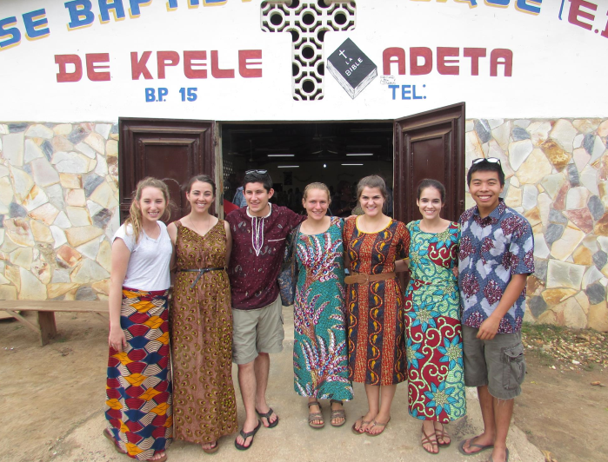

# APPENDICES

**Appendix A – Distance from Acceleration trial Data**

Actually went 19”

**Appendix B – TeleOp**

**Tele-Op**

#pragma config(Hubs, S1, HTMotor, HTMotor, HTMotor, HTServo)

#pragma config(Sensor, S1, , sensorI2CMuxController)

#pragma config(Sensor, S2, Gyro, sensorI2CHiTechnicGyro)

#pragma config(Sensor, S3, mux, sensorI2CCustom)

#pragma config(Sensor, S4, ir, sensorHiTechnicIRSeeker1200)

#pragma config(Motor, mtr_S1_C1_1, leftFront, tmotorTetrix, openLoop)

#pragma config(Motor, mtr_S1_C1_2, leftRear, tmotorTetrix, openLoop, encoder)

#pragma config(Motor, mtr_S1_C2_1, rightFront, tmotorTetrix, openLoop, reversed)

#pragma config(Motor, mtr_S1_C2_2, rightRear, tmotorTetrix, openLoop, reversed, encoder)

#pragma config(Motor, mtr_S1_C3_1, lift, tmotorTetrix, openLoop, encoder)

#pragma config(Motor, mtr_S1_C3_2, intake, tmotorTetrix, openLoop)

#pragma config(Servo, srvo_S1_C4_1, inputstop, tServoStandard)

#pragma config(Servo, srvo_S1_C4_2, hook1, tServoStandard)

#pragma config(Servo, srvo_S1_C4_3, hook2, tServoStandard)

#pragma config(Servo, srvo_S1_C4_4, irTurret, tServoStandard)

#pragma config(Servo, srvo_S1_C4_5, ultraTurret, tServoStandard)

#pragma config(Servo, srvo_S1_C4_6, output, tServoStandard)

//*!!Code automatically generated by 'ROBOTC' configuration wizard !!*//

#define light msensor_S3_1

#define touch msensor_S3_2

#define accel msensor_S3_3

#define ultraSonic msensor_S3_4

//*!!Code automatically generated by 'ROBOTC' configuration wizard !!*//

/////////////////////////////////////////////////////////////////////////////////////////////////////

//

// Tele-Operation Mode Code Template

//

// This file contains a template for simplified creation of an tele-op program for an FTC

// competition.

//

// You need to customize two functions with code unique to your specific robot.

//

/////////////////////////////////////////////////////////////////////////////////////////////////////

#include "JoystickDriver.c" //Include file to "handle" the Bluetooth messages.

#include "hitechnic-sensormux.h"

#include "lego-light.h"

#include "lego-touch.h"

#include "Buttonmap.h"

int deadband = 10;

float driveFraction = 1.0;

bool driving = false;

bool runIntake = true;

bool closeOverride = false;

int driveStyle = 0;

task AwesomeDrive;

task LameDrive;

task Arm;

task Buttons;

/////////////////////////////////////////////////////////////////////////////////////////////////////

//

// initializeRobot

//

// Prior to the start of tele-op mode, you may want to perform some initialization on your robot

// and the variables within your program.

//

// In most cases, you may not have to add any code to this function and it will remain "empty".

//

/////////////////////////////////////////////////////////////////////////////////////////////////////

void initializeRobot()

{

servo[output] = 130;

servo[hook1] = 255;

servo[hook2] = 0;

servo[irTurret] = 255;

return;

}

/////////////////////////////////////////////////////////////////////////////////////////////////////

//

// Main Task

//

// The following is the main code for the tele-op robot operation. Customize as appropriate for

// your specific robot.

//

// Game controller / joystick information is sent periodically (about every 50 milliseconds) from

// the FMS (Field Management System) to the robot. Most tele-op programs will follow the following

// logic:

// 1. Loop forever repeating the following actions:

// 2. Get the latest game controller / joystick settings that have been received from the PC.

// 3. Perform appropriate actions based on the joystick + buttons settings. This is usually a

// simple action:

// * Joystick values are usually directly translated into power levels for a motor or

// position of a servo.

// * Buttons are usually used to start/stop a motor or cause a servo to move to a specific

// position.

// 4. Repeat the loop.

//

// Your program needs to continuously loop because you need to continuously respond to changes in

// the game controller settings.

//

// At the end of the tele-op period, the FMS will autonmatically abort (stop) execution of the program.

//

/////////////////////////////////////////////////////////////////////////////////////////////////////

task AwesomeDrive()

{

//Define storage variables

int rawX, rawY;

float shapedX, shapedY;

float leftPower, rightPower;

driveStyle = 0;

while (true)

{

//Get joystick data

getJoystickSettings(joystick);

//Check if the joystick is being used on any axis

if (abs(joystick.joy1_x1) > deadband)

rawX = joystick.joy1_x1 - (sgn(joystick.joy1_x1) * deadband); //Set variables and subtract deadband from total to avoid jump

else

rawX = 0;

if (abs(joystick.joy1_y1) > deadband)

rawY = joystick.joy1_y1 - (sgn(joystick.joy1_y1) * deadband); //Set variables and subtract deadband from total to avoid jump

else

rawY = 0;

//Shape the powers based on equation: y = (2/225)(x*abs(x))+(14/45)x

shapedX = 0.0088888888888889 * (rawX * abs(rawX)) + 0.3111111111111111 * rawX;

shapedY = 0.0088888888888889 * (rawY * abs(rawY)) + 0.3111111111111111 * rawY;

//shapedX = (float)(2/225) * (rawX * abs(rawX)) + (float)(14/45) * rawX;

//shapedY = (float)(2/225) * (rawY * abs(rawY)) + (float)(14/45) * rawY;

//Determine power of each side by slowing one side and increasing the other appropriately

leftPower = shapedY - shapedX/2;

rightPower = shapedY + shapedX/2;

//Finally, set the power to the motors

motor[leftFront] = leftPower * driveFraction;

motor[leftRear] = leftPower * driveFraction;

motor[rightFront] = rightPower * driveFraction;

motor[rightRear] = rightPower * driveFraction;

if (abs(leftPower) > 0 || abs(rightPower) > 0)

driving = true;

else

driving = false;

if (joy1Btn(BTN_SELECT))

{

wait10Msec(30);

StartTask(LameDrive);

break;

}

}

}

task LameDrive()

{

//Define storage variables

int rawLeft, rawRight;

float shapedLeft, shapedRight;

driveStyle = 1;

while (true)

{

//Get joystick data

getJoystickSettings(joystick);

//Check if the joystick is being used on any axis

if (abs(joystick.joy1_y1) > deadband)

rawLeft = joystick.joy1_y1 - (sgn(joystick.joy1_y1) * deadband); //Set variables and subtract deadband from total to avoid jump

else

rawLeft = 0;

if (abs(joystick.joy1_y2) > deadband)

rawRight = joystick.joy1_y2 - (sgn(joystick.joy1_y2) * deadband); //Set variables and subtract deadband from total to avoid jump

else

rawRight = 0;

//Shape the powers based on equation: y = (2/225)(x*abs(x))+(14/45)x

shapedRight = 0.0088888888888889 * (rawLeft * abs(rawLeft)) + 0.3111111111111111 * rawLeft;

shapedLeft = 0.0088888888888889 * (rawRight * abs(rawRight)) + 0.3111111111111111 * rawRight;

//Finally, set the power to the motors

motor[leftFront] = shapedLeft * driveFraction;

motor[leftRear] = shapedLeft * driveFraction;

motor[rightFront] = shapedRight * driveFraction;

motor[rightRear] = shapedRight * driveFraction;

if (abs(shapedLeft) > 0 || abs(shapedRight) > 0)

driving = true;

else

driving = false;

if (joy1Btn(BTN_SELECT))

{

wait10Msec(30);

StartTask(AwesomeDrive);

break;

}

}

}

task Arm()

{

int count = 0;

float lightAvg = LSvalRaw(light);

float lightVal = 0;

bool bucketFull = false;

bool counted = false;

LSsetActive(light);

while(true)

{

getJoystickSettings(joystick);

if (joy1Btn(BTN_LB) && !joy1Btn(BTN_LT))

motor[lift] = 75;

else if (joy1Btn(BTN_LT) && !joy1Btn(BTN_LB))

motor[lift] = -75;

else

motor[lift] = 0;

if (joy1Btn(BTN_RB) && !joy1Btn(BTN_RT) && runIntake)

motor[intake] = 100;

else if (joy1Btn(BTN_RT) && !joy1Btn(BTN_RB) && runIntake)

motor[intake] = -100;

else

motor[intake] = 0;

lightVal = LSvalRaw(light);

//writeDebugStreamLine("Count: %d", count);

//writeDebugStreamLine("Avg: %d", lightAvg);

//writeDebugStreamLine("Val: %d", lightVal);

if (lightVal > (lightAvg + 23) && !counted && time1[T3] > 1200)

{

count += 1;

counted = true;

writeDebugStreamLine("Count: %d", count);

writeDebugStreamLine("Avg: %d", lightAvg);

writeDebugStreamLine("Val: %d", lightVal);

ClearTimer(T3);

}

else if (counted && lightAvg < (lightVal + 15))

{

counted = false;

}

else if (time1[T2] > 500)

{

lightAvg = (lightAvg + lightVal)/2;

ClearTimer(T2);

}

if (count == 5)

{

bucketFull = true;

ClearTimer(T1);

count = 0;

}

if (time10[T1] > 300 && bucketFull)

{

runIntake = false;

bucketFull = false;

}

if (TSreadState(touch) == 1 && !closeOverride)

servo[inputstop] = 130;

else if (TSreadState(touch) == 0 && !closeOverride)

servo[inputstop] = 235;

if (time1[T4] > 5000)

closeOverride = false;

}

}

task Buttons()

{

while (true)

{

getJoystickSettings(joystick);

if (joy1Btn(BTN_A))

{

if (servo[output] < 190)

servo[output] = 244;

else

servo[output] = 130;

runIntake = true;

wait10Msec(40);

}

if (joy1Btn(BTN_Y))

{

closeOverride = true;

ClearTimer(T4);

if (servo[inputstop] < 190)

servo[inputstop] = 235;

else

servo[inputstop] = 130;

wait10Msec(40);

}

if (joy1Btn(BTN_B))

{

runIntake = true;

}

if (joy1Btn(BTN_X))

{

if (servo[hook1] > 180)

{

servo[hook1] = 0;

servo[hook2] = 255;

}

else

{

servo[hook1] = 255;

servo[hook2] = 0;

}

wait10Msec(40);

}

}

}

task main()

{

initializeRobot();

waitForStart(); // wait for start of tele-op phase

clearDebugStream();

StartTask(AwesomeDrive);

StartTask(Arm);

StartTask(Buttons);

long messageCountPrev = 0;

while (true)

{

if (messageCountPrev == ntotalMessageCount)

{

StopTask(AwesomeDrive);

StopTask(Arm);

StopTask(Buttons);

StopTask(LameDrive);

motor[mtr_S1_C2_1] = 0;

motor[mtr_S1_C2_2] = 0;

motor[mtr_S1_C3_1] = 0;

motor[mtr_S1_C3_2] = 0;

motor[mtr_S1_C4_1] = 0;

motor[mtr_S1_C4_2] = 0;

wait10Msec(100);

StartTask((driveStyle == 0) ? AwesomeDrive : LameDrive);

StartTask(Arm);

StartTask(Buttons);

}

messageCountPrev = ntotalMessageCount;

wait10Msec(100);

}

}

**Appendix C – Autonomous Functions**

**Move**

//Move Function

void Move(float Distance, float Speed)

{

float countsPerInch = 20;

float userSpeed = 0.0, distTrav = 0.0, time = 0.0, powerShiftConst = 0.3, speedPercent = 0.0;

float leftPower = 0.0, rightPower = 0.0, leftSpeed = 0.0, rightSpeed = 0.0;

long leftEncodCount = 0.0, rightEncodCount = 0.0, prevLeftEncodCount = 0.0, prevRightEncodCount = 0.0;

int direction = sgn(Distance);

Distance = abs(Distance);

Distance *= countsPerInch;

Speed *= countsPerInch;

userSpeed = Speed;

leftPower = 5;

rightPower = 5;

nMotorEncoder[rightRear] = 0;

nMotorEncoder[leftRear] = 0;

ClearTimer(T1);

motor[leftFront] = leftPower;

motor[leftRear] = leftPower;

motor[rightFront] = rightPower;

motor[rightRear] = rightPower;

float timeElapsed = 0.0;

float iterations = 0;

Speed = 0;

while (distTrav < Distance)

{

time = time1[T1] / 1000;

leftEncodCount = nMotorEncoder[leftRear];

rightEncodCount = nMotorEncoder[rightRear];

/*if (iterations < 1.0)

{

timeElapsed += time;

if (timeElapsed > iterations)

{

Speed += 0.25;

iterations += 0.2;

}

}

else

Speed = userSpeed;*/

speedPercent = -1 * log(distTrav/Distance);

if (speedPercent > 1)

speedPercent = 1;

Speed *= speedPercent;

distTrav = (leftEncodCount + rightEncodCount) / 2;

leftSpeed = (leftEncodCount - prevLeftEncodCount) / time;

rightSpeed = (rightEncodCount - prevRightEncodCount) / time;

if (leftSpeed == 0)

leftSpeed = Speed;

if (rightSpeed == 0)

rightSpeed = Speed;

leftPower += (Speed - leftSpeed) * powerShiftConst;

rightPower += (Speed - rightSpeed) * powerShiftConst;

if (abs(leftPower) > 100)

leftPower = 100 * sgn(leftPower);

if (abs(rightPower) > 100)

rightPower = 100 * sgn(rightPower);

motor[leftFront] = direction * leftPower;

motor[leftRear] = direction * leftPower;

motor[rightFront] = direction * rightPower;

motor[rightRear] = direction * rightPower;

prevLeftEncodCount = nMotorEncoder[leftRear];

prevRightEncodCount = nMotorEncoder[rightRear];

ClearTimer(T1);

writeDebugStreamLine("left: %d", leftEncodCount);

writeDebugStreamLine("right: %d", rightEncodCount);

writeDebugStreamLine("distance: %d", Distance);

writeDebugStreamLine("distTrav: %d", distTrav);

}

motor[leftFront] = 0;

motor[leftRear] = 0;

motor[rightFront] = 0;

motor[rightRear] = 0;

}

**Turn**

void Turn( float turnDegrees )

{

// Store new bias

GyroBias = ((float)avgdata / 20);

int state = 2;

int time;

int time_old = 0;

int delta_time;

float maxVelocity = 180.0; // max angular velocity in deg/sec

float GyroOld;

float GyroNew;

int rotDirection = 1;

int motorSpeed = 0;

float DegreeGain = 5.0;

float degreesToGo;

int MAX_GYRO_SPEED = 85; //maximum motor speed allowed in turns

int MIN_GYRO_SPEED = 40; //minimum motor speed allowed in turns

float Angle;

// Determine the rotation direction. Set to negative for clock-wise rotation.

if( turnDegrees < 0 ) rotDirection = -1;

// Set the Angle and components to zero befor turning

Angle = 0.0;

degreesToGo = 0.0;

time_old = nPgmTime;

GyroOld = 0.0;

wait1Msec(100);

// remove the backlash and freeplay from the motors before zeroing the encoders by commanding

// a very low power for a short time

motorSpeed = 5;

motor[B_L] = -rotDirection * motorSpeed;

motor[B_R] = rotDirection * motorSpeed;

wait1Msec(10);

// reset the back motor encoders to zero

nMotorEncoder[B_R] = 0;

nMotorEncoder[B_L] = 0;

ClearTimer(T3);

//---------------------------------------------------------------------------

// Move the motors until the gyro Angle indicates the rotation is complete

//---------------------------------------------------------------------------

while( ( abs(turnDegrees) - abs(Angle) ) > 3 )

{

time = nPgmTime; // this timer wraps around

delta_time = abs(time - time_old); // delta time in ms

if (delta_time < 1) // protect against divide by zero

{

delta_time = 1;

}

// read the gyro sensor minus the bias offset. GyroBias must be declared and

// computed in the calling program.

GyroNew = -((float)SensorValue[Gyro] - GyroBias);

// limit the gyro to the max achievable by the bot to minimize data spikes.

if (abs(GyroNew) > maxVelocity) GyroNew = sgn(GyroNew)*maxVelocity;

// deadband for the gyro to eliminate drift due to noise

if (abs(GyroNew) <= 0.2) GyroNew = 0.0;

// compute the integral of the angular rate using a trapazoidal approximation

// http://en.wikipedia.org/wiki/Numerical_integration

Angle = Angle + 0.001 * (float)delta_time * 0.5 *(GyroNew + GyroOld);

// update the old values for the next time through the loop

time_old = time;

GyroOld = GyroNew;

// Calculate the rotation remaining

degreesToGo = abs(turnDegrees) - abs(Angle);

// motor speed is proportional to the amount of rotation remaining

motorSpeed = (int)(DegreeGain * abs(degreesToGo));

// limit the motor speed to be greater than 15 and less than 75

if (abs(motorSpeed) > MAX_GYRO_SPEED) motorSpeed = MAX_GYRO_SPEED;

if (abs(motorSpeed) < MIN_GYRO_SPEED) motorSpeed = MIN_GYRO_SPEED;

motor[B_L] = rotDirection * motorSpeed ; // looking from the top, left side moves back, right

motor[B_R] = -rotDirection * motorSpeed ; // side moves forward for (+) CCW rotation

if( time100[T3] > 50 ) break; // if the bot is not done turning in 5 sec, quit

wait1Msec(15); // wait 20 ms to allow a reasonable period for the integration

} // End while rotation remaining

// since we have now reached the target rotation (the while loop is done), stop all drive motors

motor[B_R] = 0;

motor[B_L] = 0;

// reset the back motor encoders to zero

nMotorEncoder[B_R] = 0;

nMotorEncoder[B_L] = 0;

} // End of Turn_Gyro()

**Distance from Acceleration**

void Move(float distance, float power)

{

float offset = 0;

int xRaw, yRaw, zRaw = 0;

float xAccel = 0;

float prevXAccel = 0;

float prevXRaw = 0;

int timeOld = 0;//, timeNew = 0;

float deltaTime = 0;

float velocity = 0;

float prevVelocity = 0;

float dist = 0;

//float mPowers = 0;

power = abs(power) * sgn(distance);

distance = abs(distance);

float accelBias = 0;

for (int i = 0; i < 20; i++)

{

HTACreadAllAxes(accel, xRaw, yRaw, zRaw);

accelBias += sqrt((xRaw * xRaw)+(yRaw * yRaw)+(zRaw * zRaw));

//accelBias += xRaw;

}

offset = accelBias/20;

clearDebugStream();

ClearTimer(T1);

//timeNew = nPgmTime;

int rampUpCount = 300*0.05;

while (true)

{

if (abs(dist) < distance)

{

if (rampUpCount <= 300)

rampUpCount += 1;

motor[rightDrive] = power * rampUpCount/100;

motor[leftDrive] = power * rampUpCount/100;

HTACreadAllAxes(accel, xRaw, yRaw, zRaw);

xAccel = (sqrt((xRaw * xRaw)+(yRaw * yRaw)+(zRaw * zRaw)-(offset*offset)) / 200.0) * 386.09;

//xAccel = (((float)xRaw - (float)offset) / 200.0) * 386.09;

//writeDebugStreamLine("%f",xAccel);

deltaTime = time1[T1] * 0.001;

//deltaTime = (timeNew - timeOld) * 0.001;

if (abs(xAccel) <= 0.1)

xAccel = 0;

velocity += deltaTime/2 * (prevXAccel + xAccel);

dist += deltaTime/2 * (prevVelocity + velocity);

//writeDebugStreamLine("Accel: %f", xAccel);

ClearTimer(T1);

//timeOld = timeNew;

prevXAccel = xAccel;

prevVelocity = velocity;

//wait1Msec(10);

/*prevXRaw = xRaw;

do

{

HTACreadAllAxes(accel, xRaw, yRaw, zRaw);

}while(xRaw == prevXRaw);*/

}

else

{

motor[rightDrive] = 0;

motor[leftDrive] = 0;

}

}

}

**I2C Master Bit Banging Tests**

#pragma config(Sensor, S1, , sensorI2CCustom)

//*!!Code automatically generated by 'ROBOTC' configuration wizard !!*//

/////////////////////////////////////////////////////////////////////////////////////////////////////

//

// Autonomous Mode Code Template

//

// This file contains a template for simplified creation of an autonomous program for an TETRIX robot

// competition.

//

// You need to customize two functions with code unique to your specific robot.

//

/////////////////////////////////////////////////////////////////////////////////////////////////////

#include "JoystickDriver.c" //Include file to "handle" the Bluetooth messages.

#include "common.h"

#define clock 0x02 //B1

#define data 0x01 //B0

bool scl = false;

bool sda = false;

byte buffer[10];

/////////////////////////////////////////////////////////////////////////////////////////////////////

//

// initializeRobot

//

// Prior to the start of autonomous mode, you may want to perform some initialization on your robot.

// Things that might be performed during initialization include:

// 1. Move motors and servos to a preset position.

// 2. Some sensor types take a short while to reach stable values during which time it is best that

// robot is not moving. For example, gyro sensor needs a few seconds to obtain the background

// "bias" value.

//

// In many cases, you may not have to add any code to this function and it will remain "empty".

//

/////////////////////////////////////////////////////////////////////////////////////////////////////

void initializeRobot()

{

// Place code here to sinitialize servos to starting positions.

// Sensors are automatically configured and setup by ROBOTC. They may need a brief time to stabilize.

return;

}

/////////////////////////////////////////////////////////////////////////////////////////////////////

//

// Main Task

//

// The following is the main code for the autonomous robot operation. Customize as appropriate for

// your specific robot.

//

// The types of things you might do during the autonomous phase (for the 2008-9 FTC competition)

// are:

//

// 1. Have the robot follow a line on the game field until it reaches one of the puck storage

// areas.

// 2. Load pucks into the robot from the storage bin.

// 3. Stop the robot and wait for autonomous phase to end.

//

// This simple template does nothing except play a periodic tone every few seconds.

//

// At the end of the autonomous period, the FMS will autonmatically abort (stop) execution of the program.

//

/////////////////////////////////////////////////////////////////////////////////////////////////////

//General I2C Communication Functions

/***************************************************************/

void writeLines()

{

scl = !scl;

sda = !sda;

tByteArray msg;

msg[0] = 3;

msg[1] = 0x10;

msg[2] = 0x4E;

msg[3] = (scl && sda) ? (clock + data) : (scl ? clock : (sda ? data : 0x00));

writeI2C(S1, msg);

scl = !scl;

sda = !sda;

msg[2] = 0x4D;

msg[3] = (scl && sda) ? (clock + data) : (scl ? clock : (sda ? data : 0x00));

writeI2C(S1, msg);

}

void clockHi()

{

scl = true;

writeLines();

}

void clockLo()

{

scl = false;

writeLines();

}

bool checkClock()

{

tByteArray msg;

msg[0] = 2;

msg[1] = 0x10;

msg[2] = 0x4C;

tByteArray reply;

writeI2C(S1, msg, reply, 1);

if ((reply[0] & clock) > 0)

return true;

else

return false;

}

void dataHi()

{

sda = true;

writeLines();

}

void dataLo()

{

sda = false;

writeLines();

}

bool checkData()

{

tByteArray msg;

msg[0] = 2;

msg[1] = 0x10;

msg[2] = 0x4C;

tByteArray reply;

writeI2C(S1, msg, reply, 1);

if ((reply[0] & data) > 0)

return true;

else

return false;

}

void delay()

{

int _random = 0;

for (int i = 0; i <= 5; i++)

_random += 1;

}

void i2cStart()

{

dataHi();

delay();

clockHi();

delay();

dataLo();

delay();

clockLo();

delay();

}

void i2cStop()

{

clockLo();

delay();

dataLo();

delay();

clockHi();

delay();

dataHi();

delay();

}

void i2cTx(ubyte d)

{

for (int x = 8; x > 0; x--)

{

if (d & 0x80)

dataHi();

else

dataLo();

delay();

clockHi();

d <<= 1;

clockLo();

}

delay();

dataHi();

clockHi();

while (!checkClock()){}

//Ack comes here

delay();

clockLo();

}

void writeData(ubyte a, ubyte iA, ubyte d)

{

a <<= 1;

i2cStart();

i2cTx(a);

i2cTx(iA);

i2cTx(d);

i2cStop();

}

byte i2cRx(bool ack)

{

ubyte d = 0;

dataHi();

for(int x = 0; x < 8; x++)

{

d <<= 1;

clockHi();

while(!checkClock()){}

delay();

bool t = checkData();

d |= (int)t;

writeDebugStreamLine("%d", t);

clockLo();

}

if (ack)

dataLo();

else

dataHi();

clockHi();

delay();

clockLo();

dataHi();

return d;

}

void readData(ubyte a, ubyte iA, int bytesToRead)

{

a <<= 1;

i2cStart();

i2cTx(a);

i2cTx(iA);

i2cStart();

i2cTx(a + 1);

int last = 0;

for (int i = 0; i < bytesToRead - 1; i++)

{

buffer[i] = i2cRx(true);

last = i + 1;

}

buffer[last] = i2cRx(false);

i2cStop();

}

/***************************************************************/

//Sensor Specific Functions

#define accelAddr 0x53

#define powerCtrlAddr 0x2D

#define dataFormatAddr 0x31

#define xAddr0 0x32

#define yAddr0 0x34

#define zAddr0 0x36

void setupAccel()

{

writeData(accelAddr, dataFormatAddr, 0x01);

writeData(accelAddr, dataFormatAddr, 0x08);

}

int xAccel = 0.0;

int yAccel = 0.0;

int zAccel = 0.0;

void updateAcceleration()

{

readData(accelAddr, xAddr0, 6);

xAccel = (((int)buffer[0]) << 8) | buffer[1];

yAccel = (((int)buffer[2]) << 8) | buffer[3];

zAccel = (((int)buffer[4]) << 8) | buffer[5];

}

task main()

{

initializeRobot();

//waitForStart(); // Wait for the beginning of autonomous phase.

clearDebugStream();

setupProtoBoard();

setupAccel();

bool t = false;

while (true)

{

updateAcceleration();

writeDebugStreamLine("X Accel: %f", checkData());

/*if (t)

dataHi();

else

dataLo();

t = !t;

sleep(3000);*/

}

}

**Appendix D – Autonomous Programs**

**Ramp Autonomy**

#pragma config(Hubs, S1, HTMotor, HTMotor, HTMotor, HTServo)

#pragma config(Sensor, S1, , sensorI2CMuxController)

#pragma config(Sensor, S2, Gyro, sensorI2CHiTechnicGyro)

#pragma config(Sensor, S3, mux, sensorI2CCustom)

#pragma config(Sensor, S4, ir, sensorHiTechnicIRSeeker1200)

#pragma config(Motor, mtr_S1_C1_1, leftFront, tmotorTetrix, openLoop)

#pragma config(Motor, mtr_S1_C1_2, leftRear, tmotorTetrix, openLoop, encoder)

#pragma config(Motor, mtr_S1_C2_1, rightFront, tmotorTetrix, openLoop, reversed)

#pragma config(Motor, mtr_S1_C2_2, rightRear, tmotorTetrix, openLoop, reversed, encoder)

#pragma config(Motor, mtr_S1_C3_1, lift, tmotorTetrix, openLoop, encoder)

#pragma config(Motor, mtr_S1_C3_2, intake, tmotorTetrix, openLoop)

#pragma config(Servo, srvo_S1_C4_1, inputstop, tServoStandard)

#pragma config(Servo, srvo_S1_C4_2, hook1, tServoStandard)

#pragma config(Servo, srvo_S1_C4_3, hook2, tServoStandard)

#pragma config(Servo, srvo_S1_C4_4, irTurret, tServoStandard)

#pragma config(Servo, srvo_S1_C4_5, ultraTurret, tServoStandard)

#pragma config(Servo, srvo_S1_C4_6, output, tServoStandard)

//*!!Code automatically generated by 'ROBOTC' configuration wizard !!*//

#define light msensor_S3_1

#define touch msensor_S3_2

#define accel msensor_S3_3

#define ultraSonic msensor_S3_4

//*!!Code automatically generated by 'ROBOTC' configuration wizard !!*//

/////////////////////////////////////////////////////////////////////////////////////////////////////

//

// Autonomous Mode Code Template

//

// This file contains a template for simplified creation of an autonomous program for an TETRIX robot

// competition.

//

// You need to customize two functions with code unique to your specific robot.

//

/////////////////////////////////////////////////////////////////////////////////////////////////////

float GyroBias = 0;

#include "JoystickDriver.c" //Include file to "handle" the Bluetooth messages.

#include "newMove.c"

#include "turn_gyro_2_wheel.c"

#include "hitechnic-sensormux.h"

#include "hitechnic-accelerometer.h"

#include "hitechnic-irseeker-v2.h"

#include "lego-touch.h"

#include "lego-light.h"

#include "lego-ultrasound.h"

/////////////////////////////////////////////////////////////////////////////////////////////////////

//

// initializeRobot

//

// Prior to the start of autonomous mode, you may want to perform some initialization on your robot.

// Things that might be performed during initialization include:

// 1. Move motors and servos to a preset position.

// 2. Some sensor types take a short while to reach stable values during which time it is best that

// robot is not moving. For example, gyro sensor needs a few seconds to obtain the background

// "bias" value.

//

// In many cases, you may not have to add any code to this function and it will remain "empty".

//

/////////////////////////////////////////////////////////////////////////////////////////////////////

float avgdata = 0;

void initializeRobot()

{

servo[hook1] = 0;

servo[hook2] = 255;

servo[output] = 130;

servo[inputstop] = 235;

servo[irTurret] = 255;

for (int i = 0; i < 20; i++)

{

avgdata += SensorValue[Gyro];

wait1Msec(25);

}

GyroBias = ((float)avgdata / 20);

return;

}

/////////////////////////////////////////////////////////////////////////////////////////////////////

//

// Main Task

//

// The following is the main code for the autonomous robot operation. Customize as appropriate for

// your specific robot.

//

// The types of things you might do during the autonomous phase (for the 2008-9 FTC competition)

// are:

//

// 1. Have the robot follow a line on the game field until it reaches one of the puck storage

// areas.

// 2. Load pucks into the robot from the storage bin.

// 3. Stop the robot and wait for autonomous phase to end.

//

// This simple template does nothing except play a periodic tone every few seconds.

//

// At the end of the autonomous period, the FMS will autonmatically abort (stop) execution of the program.

//

/////////////////////////////////////////////////////////////////////////////////////////////////////

float getUltraAngle()

{

int servoVal = 42;

int endPos = 180;

servo[ultraTurret] = servoVal;

wait10Msec(100);

int count = 0;

while (servoVal <= endPos)

{

servoVal++;

servo[ultraTurret] = servoVal;

if (USreadDist(ultraSonic) > 20 && USreadDist(ultraSonic) < 40)

count++;

else

count = 0;

if (count > 20)

break;

wait10Msec(1);

}

if (servoVal < endPos)

return (float)servoVal * 180.0 / 256.0;

else

return -1;

}

task main()

{

initializeRobot();

waitForStart(); // Wait for the beginning of autonomous phase.

clearDebugStream();

//Off ramp

Move(-75, 0.5);

wait10Msec(10);

//Precision Line-Up

if (TSreadState(touch) == 1)

{

motor[lift] = 75;

bool raising = false;

nMotorEncoder[lift] = 0;

while (abs(nMotorEncoder[lift]) <= 500)

{

if (TSreadState(touch) != 1 && !raising)

{

nMotorEncoder[lift] = 0;

raising = true;

}

wait10Msec(10);

}

motor[lift] = 0;

}

float Angle = 0;

while (true)

{

Angle = getUltraAngle();

if (Angle == -1)

Move(-5, 0.3);

else if (Angle >= 86 && Angle <= 90)

break;

else

{

Turn(Angle - 88);

}

}

float dist = USreadDist(ultraSonic)/2.54;

Move(-(dist - 6), 0.1);

//grab goal

wait10Msec(100);

servo[hook1] = 235;

servo[hook2] = 30;

wait10Msec(30);

Turn(30);

wait10Msec(10);

Move(110, 1);

wait10Msec(10);

Turn(150);

wait10Msec(10);

//score

//motor[lift] = 75;

bool raising = false;

nMotorEncoder[lift] = 0;

while (abs(nMotorEncoder[lift]) <= 14710)

{

if (TSreadState(touch) != 1 && !raising)

{

nMotorEncoder[lift] = 0;

raising = true;

}

if (raising)

writeDebugStreamLine("%f", nMotorEncoder[lift]);

wait10Msec(10);

}

motor[lift] = 0;

Move(3, 0.2);

wait10Msec(10);

servo[output] = 250;

wait10Msec(500);

//release goal

servo[hook1] = 255;

servo[hook2] = 0;

wait10Msec(300);

Move(5, 1);

wait10Msec(30);

Turn(180);

}

**Zone Autonomy**

#pragma config(Hubs, S1, HTMotor, HTMotor, HTMotor, HTServo)

#pragma config(Sensor, S1, , sensorI2CMuxController)

#pragma config(Sensor, S2, Gyro, sensorI2CHiTechnicGyro)

#pragma config(Sensor, S3, mux, sensorI2CCustom)

#pragma config(Sensor, S4, ir, sensorHiTechnicIRSeeker1200)

#pragma config(Motor, mtr_S1_C1_1, leftFront, tmotorTetrix, openLoop)

#pragma config(Motor, mtr_S1_C1_2, leftRear, tmotorTetrix, openLoop, encoder)

#pragma config(Motor, mtr_S1_C2_1, rightFront, tmotorTetrix, openLoop, reversed)

#pragma config(Motor, mtr_S1_C2_2, rightRear, tmotorTetrix, openLoop, reversed, encoder)

#pragma config(Motor, mtr_S1_C3_1, lift, tmotorTetrix, openLoop, encoder)

#pragma config(Motor, mtr_S1_C3_2, intake, tmotorTetrix, openLoop)

#pragma config(Servo, srvo_S1_C4_1, inputstop, tServoStandard)

#pragma config(Servo, srvo_S1_C4_2, hook1, tServoStandard)

#pragma config(Servo, srvo_S1_C4_3, hook2, tServoStandard)

#pragma config(Servo, srvo_S1_C4_4, irTurret, tServoStandard)

#pragma config(Servo, srvo_S1_C4_5, ultraTurret, tServoStandard)

#pragma config(Servo, srvo_S1_C4_6, output, tServoStandard)

//*!!Code automatically generated by 'ROBOTC' configuration wizard !!*//

#define light msensor_S3_1

#define touch msensor_S3_2

#define accel msensor_S3_3

#define ultraSonic msensor_S3_4

//*!!Code automatically generated by 'ROBOTC' configuration wizard !!*//

/////////////////////////////////////////////////////////////////////////////////////////////////////

//

// Autonomous Mode Code Template

//

// This file contains a template for simplified creation of an autonomous program for an TETRIX robot

// competition.

//

// You need to customize two functions with code unique to your specific robot.

//

/////////////////////////////////////////////////////////////////////////////////////////////////////

float GyroBias = 0;

#include "JoystickDriver.c" //Include file to "handle" the Bluetooth messages.

#include "newMove.c"

#include "turn_gyro_2_wheel.c"

#include "hitechnic-sensormux.h"

#include "hitechnic-accelerometer.h"

#include "hitechnic-irseeker-v2.h"

#include "lego-touch.h"

#include "lego-light.h"

#include "lego-ultrasound.h"

/////////////////////////////////////////////////////////////////////////////////////////////////////

//

// initializeRobot

//

// Prior to the start of autonomous mode, you may want to perform some initialization on your robot.

// Things that might be performed during initialization include:

// 1. Move motors and servos to a preset position.

// 2. Some sensor types take a short while to reach stable values during which time it is best that

// robot is not moving. For example, gyro sensor needs a few seconds to obtain the background

// "bias" value.

//

// In many cases, you may not have to add any code to this function and it will remain "empty".

//

/////////////////////////////////////////////////////////////////////////////////////////////////////

float avgdata = 0;

void initializeRobot()

{

servo[hook1] = 255;

servo[hook2] = 0;

servo[output] = 130;

servo[inputstop] = 235;

for (int i = 0; i < 20; i++)

{

avgdata += SensorValue[Gyro];

wait1Msec(25);

}

GyroBias = ((float)avgdata / 20);

return;

}

/////////////////////////////////////////////////////////////////////////////////////////////////////

//

// Main Task

//

// The following is the main code for the autonomous robot operation. Customize as appropriate for

// your specific robot.

//

// The types of things you might do during the autonomous phase (for the 2008-9 FTC competition)

// are:

//

// 1. Have the robot follow a line on the game field until it reaches one of the puck storage

// areas.

// 2. Load pucks into the robot from the storage bin.

// 3. Stop the robot and wait for autonomous phase to end.

//

// This simple template does nothing except play a periodic tone every few seconds.

//

// At the end of the autonomous period, the FMS will autonmatically abort (stop) execution of the program.

//

/////////////////////////////////////////////////////////////////////////////////////////////////////

task main()

{

initializeRobot();

waitForStart(); // Wait for the beginning of autonomous phase.

clearDebugStream();

//leave zone

Move(-9.66, 1);

wait10Msec(10);

Turn(23.24);

wait10Msec(10);

Move(-51.51, 1);

wait10Msec(10);

Turn(-25);

wait10Msec(10);

Move(-42.36, 0.9);

wait10Msec(10);

Move(-10, 0.2);

//grab goal

wait10Msec(100);

servo[hook1] = 0;

servo[hook2] = 255;

wait10Msec(30);

Turn(-1.97);

wait10Msec(10);

Move(110.33, 1);

wait10Msec(10);

Turn(-90);

wait10Msec(10);

Move(-25, 0.5);

wait10Msec(10);

//score

motor[lift] = 75;

bool raising = false;

nMotorEncoder[rightFront] = 0;

while (abs(nMotorEncoder[rightFront]) <= 6000)

{

if (TSreadState(touch) != 1 && !raising)

{

nMotorEncoder[rightFront] = 0;

raising = true;

}

if (raising)

writeDebugStreamLine("%f", nMotorEncoder[rightFront]);

wait10Msec(10);

}

motor[lift] = 0;

Move(3, 0.2);

wait10Msec(10);

servo[output] = 250;

wait10Msec(500);

//release goal

servo[hook1] = 255;

servo[hook2] = 0;

wait10Msec(300);

Move(5, 1);

wait10Msec(30);

Turn(90);

}

**IR Autonomy**

#pragma config(Hubs, S1, HTMotor, HTMotor, HTMotor, HTServo)

#pragma config(Sensor, S2, Gyro, sensorI2CHiTechnicGyro)

#pragma config(Sensor, S3, mux, sensorI2CCustom)

#pragma config(Sensor, S4, ir, sensorI2CCustom)

#pragma config(Motor, mtr_S1_C1_1, leftFront, tmotorTetrix, openLoop)

#pragma config(Motor, mtr_S1_C1_2, leftRear, tmotorTetrix, openLoop, encoder)

#pragma config(Motor, mtr_S1_C2_1, rightFront, tmotorTetrix, openLoop, reversed)

#pragma config(Motor, mtr_S1_C2_2, rightRear, tmotorTetrix, openLoop, reversed, encoder)

#pragma config(Motor, mtr_S1_C3_1, lift, tmotorTetrix, openLoop, encoder)

#pragma config(Motor, mtr_S1_C3_2, intake, tmotorTetrix, openLoop)

#pragma config(Servo, srvo_S1_C4_1, inputstop, tServoStandard)

#pragma config(Servo, srvo_S1_C4_2, hook1, tServoStandard)

#pragma config(Servo, srvo_S1_C4_3, hook2, tServoStandard)

#pragma config(Servo, srvo_S1_C4_4, irTurret, tServoStandard)

#pragma config(Servo, srvo_S1_C4_5, ultraTurret, tServoStandard)

#pragma config(Servo, srvo_S1_C4_6, output, tServoStandard)

//*!!Code automatically generated by 'ROBOTC' configuration wizard !!*//

#define light msensor_S3_1

#define touch msensor_S3_2

#define accel msensor_S3_3

#define ultraSonic msensor_S3_4

//*!!Code automatically generated by 'ROBOTC' configuration wizard !!*//

/////////////////////////////////////////////////////////////////////////////////////////////////////

//

// Autonomous Mode Code Template

//

// This file contains a template for simplified creation of an autonomous program for an TETRIX robot

// competition.

//

// You need to customize two functions with code unique to your specific robot.

//

/////////////////////////////////////////////////////////////////////////////////////////////////////

float GyroBias = 0;

//#include "JoystickDriver.c" //Include file to "handle" the Bluetooth messages.

#include "newMove.c"

#include "turn_gyro_2_wheel.c"

#include "hitechnic-sensormux.h"

#include "hitechnic-accelerometer.h"

#include "hitechnic-irseeker-v2.h"

#include "lego-touch.h"

#include "lego-light.h"

#include "lego-ultrasound.h"

/////////////////////////////////////////////////////////////////////////////////////////////////////

//

// initializeRobot

//

// Prior to the start of autonomous mode, you may want to perform some initialization on your robot.

// Things that might be performed during initialization include:

// 1. Move motors and servos to a preset position.

// 2. Some sensor types take a short while to reach stable values during which time it is best that

// robot is not moving. For example, gyro sensor needs a few seconds to obtain the background

// "bias" value.

//

// In many cases, you may not have to add any code to this function and it will remain "empty".

//

/////////////////////////////////////////////////////////////////////////////////////////////////////

float avgdata = 0;

void initializeRobot()

{

HTIRS2setDSPMode(ir, DSP_1200);

servo[hook1] = 255;

servo[hook2] = 0;

servo[output] = 130;

servo[irTurret] = 230;

for (int i = 0; i < 20; i++)

{

avgdata += SensorValue[Gyro];

wait1Msec(25);

}

GyroBias = ((float)avgdata / 20);

return;

}

/////////////////////////////////////////////////////////////////////////////////////////////////////

//

// Main Task

//

// The following is the main code for the autonomous robot operation. Customize as appropriate for

// your specific robot.

//

// The types of things you might do during the autonomous phase (for the 2008-9 FTC competition)

// are:

//

// 1. Have the robot follow a line on the game field until it reaches one of the puck storage

// areas.

// 2. Load pucks into the robot from the storage bin.

// 3. Stop the robot and wait for autonomous phase to end.

//

// This simple template does nothing except play a periodic tone every few seconds.

//

// At the end of the autonomous period, the FMS will autonmatically abort (stop) execution of the program.

//

/////////////////////////////////////////////////////////////////////////////////////////////////////

float getIrAngle(bool secondary)

{

int servoVal = 0;

if (secondary)

servoVal = 144;

else

servoVal = 0;

servo[irTurret] = servoVal;

wait10Msec(100);

int irPrev = HTIRS2readACDir(ir);

while (servoVal <= 255)

{

servoVal++;

servo[irTurret] = servoVal;

writeDebugStreamLine("IR: %d", HTIRS2readACDir(ir));

if (!secondary && (HTIRS2readACDir(ir) == 4 || (irPrev == 5 && HTIRS2readACDir(ir) == 0)))

break;

else if (secondary && (HTIRS2readACDir(ir) == 6 || (irPrev == 7 && HTIRS2readACDir(ir) == 0)))

break;

irPrev = HTIRS2readACDir(ir);

wait10Msec(1);

}

if (!secondary)

return (float)(servoVal - 0) * 180.0 / 255.0;

else if (servoVal != 255)

return (float)(servoVal - 144) * 180.0 / 255.0;

else

return 0;

}

float getUltraAngle()

{

int servoVal = 42;

int endPos = 180;

servo[ultraTurret] = servoVal;

wait10Msec(100);

int count = 0;

while (servoVal <= endPos)

{

servoVal++;

servo[ultraTurret] = servoVal;

if (USreadDist(ultraSonic) > 20 && USreadDist(ultraSonic) < 60)

count++;

else

count = 0;

if (count > 20)

break;

wait10Msec(1);

}

if (servoVal < endPos)

return (float)(servoVal + 17) * 180.0 / 256.0;

else

return -1;

}

task main()

{

initializeRobot();

//waitForStart(); // Wait for the beginning of autonomous phase.

clearDebugStream();

bool pos1 = false;

servo[irTurret] = 200;

if (HTIRS2readACDir(ir) == 0)

pos1 = true;

Move(-5, 0.5);

Turn(120);

//IR Seek

float moveCounts = 20 * countsPerInch;

nMotorEncoder[leftRear] = 0;

nMotorEncoder[rightRear] = 0;

servo[irTurret] = 0;

while ((nMotorEncoder[leftRear] + nMotorEncoder[rightRear])/2 <= moveCounts)

{

//writeDebugStreamLine("%f", HTIRS2readACDir(ir));

motor[leftFront] = 35;

motor[leftRear] = 35;

motor[rightFront] = 35;

motor[rightRear] = 35;

if (HTIRS2readACDir(ir) != 0)

break;

}

motor[leftFront] = 0;

motor[leftRear] = 0;

motor[rightFront] = 0;

motor[rightRear] = 0;

wait10Msec(10);

if (pos1)

Move(18, 0.3);

Turn(getIrAngle(false) - 180);

if (TSreadState(touch) == 1)

{

motor[lift] = 75;

bool raising = false;

nMotorEncoder[lift] = 0;

while (abs(nMotorEncoder[lift]) <= 500)

{

if (TSreadState(touch) != 1 && !raising)

{

nMotorEncoder[lift] = 0;

raising = true;

}

wait10Msec(10);

}

motor[lift] = 0;

}

float Angle = 0;

//Turn(getIrAngle(true));

while (true)

{

Angle = getUltraAngle();

if (Angle == -1)

{

Move(-7, 0.3);

}

else if (Angle >= 88 && Angle <= 92)

break;

else

{

Turn(Angle - 90);

}

}

float dist = USreadDist(ultraSonic)/2.54;

Move(-(dist - 12), 0.15);

while (true){}

}

**Appendix E – Extra Autonomous Strategies**

**Zone Autonomy**

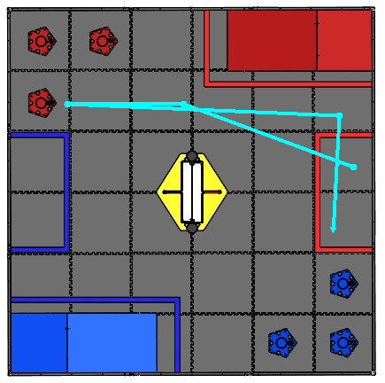

This is our main zone-start autonomous strategy. We drive out of the zone, line up with a tube, collect a tube, drop a preload into the tube, and then carry the tube back to the parking zone.

**IR Autonomy**

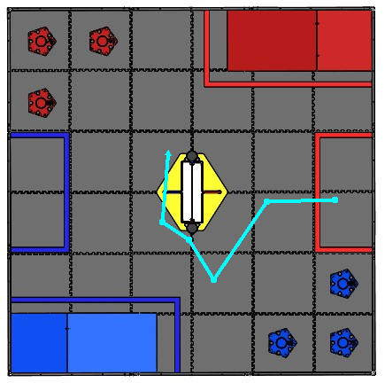

This is our IR seeking autonomous strategy. We drive out of the zone, turn around so that our IR is lined up with the center structure, we find the beacon, turn toward it and maneuver into it adjusting our trajectory constantly with the ultrasonic. We then go around the structure to knock down the kickstand. This is described in more detail in the IR and Ultrasonic sensor descriptions.

**Appendix F – Wiring diagram**

After our problems without a wiring diagram we decided that we should have one. The diagram would show us how the robot is wired so that in future reference we could just look at the diagram and it would tell us where all the wires go. This is really nice for programing because the programmers need to know what things are in what port. Because of the diagram when we have issues with the wiring and need to know how to fix them we see in the diagram how the robot was wired and then make the changes that we need.

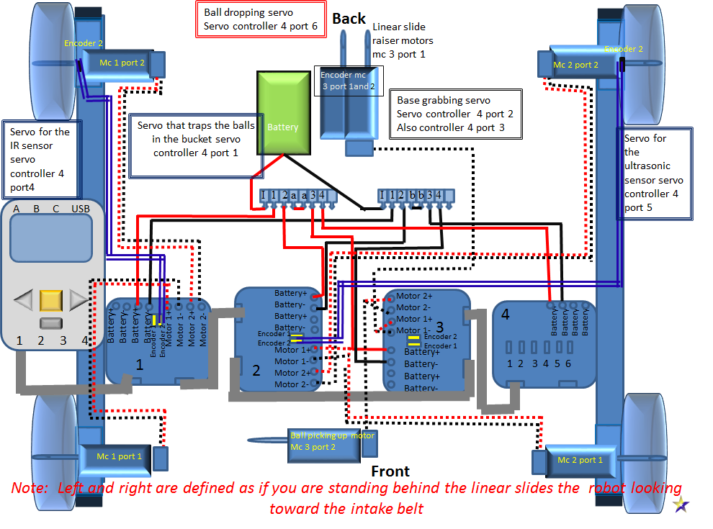

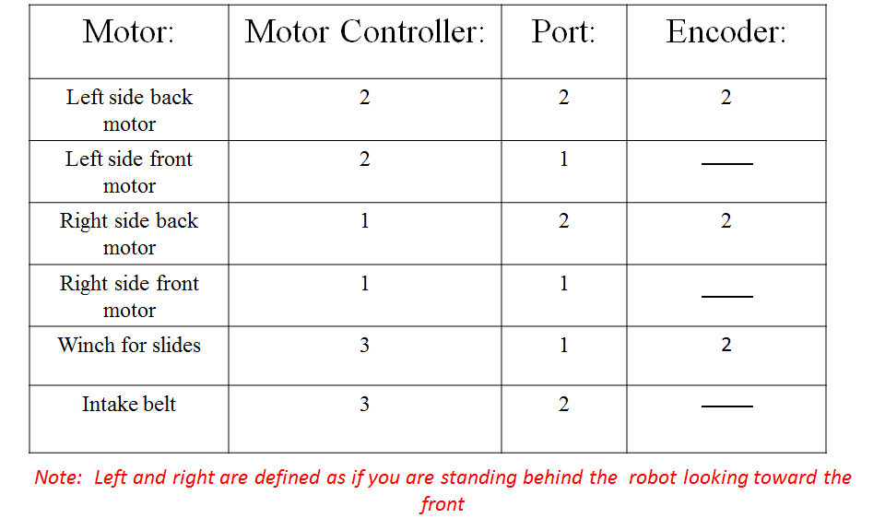

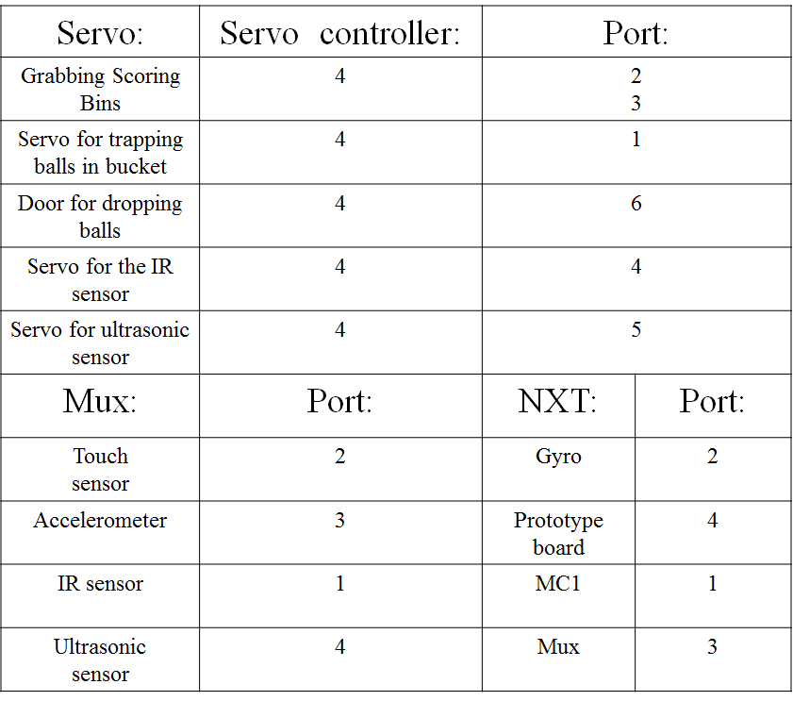

*MUX stands for Multiplexer